3.2.2 Functional Requirement

3.2.2.1. Manage Dish Category

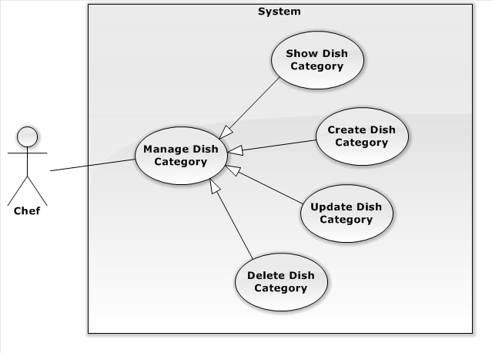

Figure 1-1: Manage Dish Category Use Case

3.2.2.1.1. Show Dish Category

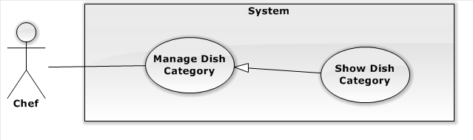

Figure 1-2: Show Dish Category Use Case

| **USE CASE SPECIFICATION** | | | |
| --- | --- | --- | --- |
| **Use-case No.** | UC001 | **Use-case Version** | 2.0 |
| **Use-case Name** | Show Dish Category | | |
| **Author** | Lê Quang Khương Duy | | |
| **Date** |  | **Priority** | High |
| **Actor:**  Chef  **Summary:**  Chef views all Dish Category in EWC service.  **Goal:**  The purpose of Show Dish Category use case is allowed Chef to request for viewing all Dish Category in the system.  **Triggers:**  Chef wants to view Dish Category in EWC service.  Chef clicks on “Danh mục Món Ăn” menu in Dish page.  **Preconditions:**  User must be logged-in as Chef-role.  **Post Conditions:**  **Success:**   * Dish Category are shown in table of “Quản Lý Danh Mục Món Ăn” screen match with search conditions.   **Failure:**   * The Chef is guided to Error page   **Main Success Scenario:**   |  |  | | --- | --- | | Actor Actions | System Response | | 1. Chef clicks on “Danh mục Món Ăn” menu in dish page. 2. Chef choose filter options or type keyword for search. | 1. Redirect to “Quản Lý Món Ăn” page contains list of Dish Category includes:   [Records per page, Drop down list includes 5, 10, 15, All, default is 5]  “Search”[Search Dish Category, Textbox]  Paging control[Paging: list of Action Link, default is set at page 1].  [Exception 1]   1. Show list of Dish Category match with search conditions. |   **Alternative Scenario:**   |  |  | | --- | --- | | Actor Actions | System Response | | N/A | N/A |     **Exceptions:**   |  |  | | --- | --- | | Actor Actions | System Response | | Exception 1   1. System fails to load data. | 1. Show Error page. |   **Relationships:**   * Manage Dish Category   **Business Rules:**   * N/A | | | |

3.2.2.1.2. Create Dish Category

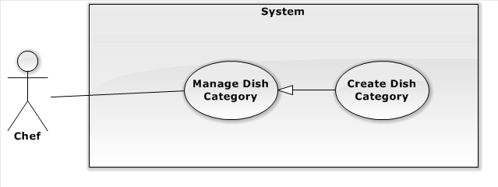

Figure 1-2: Create Dish Category Use Case

| **USE CASE SPECIFICATION** | | | |
| --- | --- | --- | --- |
| **Use-case No.** | UC001 | **Use-case Version** | 2.0 |
| **Use-case Name** | Create Dish Category | | |
| **Author** | Lê Quang Khương Duy | | |
| **Date** |  | **Priority** | High |
| **Actor:**  Chef  **Summary:**  Chef create new Dish Category for EWC service.  **Goal:**  The purpose of Create Dish Category use case is allowed Chef to request for creating new Dish Category for the system.  **Triggers:**  Chef wants to create new Dish Category in EWC service.  Chef clicks on “Danh mục Món Ăn” menu on menu bar.  Chef clicks on “Tạo Mới” button.  **Preconditions:**  User must be logged-in as Chef-role.  **Post Conditions:**  **Success:**   * Chef creates new Dish Category successful.   **Failure:**   * The Chef is presented an error message on screen.   **Main Success Scenario:**   |  |  | | --- | --- | | Actor Actions | System Response | | 1. Chef clicks on “Tạo Mới” button. 2. Chef fills Dish Category and clicks on “Lưu” button. [Alternative 1] | 1. A new empty row is created in the top of Dish Category table includes:   “Tên”[Name: Textbox, max length:100, require]  “Mô tả”[Description: text area, string]  “Hình ảnh” [Image: image picker, include a file input and a file-preview label]  “Hủy”[Button]  “Lưu”[Button]   1. Show message “Lưu thành công!”   [Exception 1] [Exception 2] [Exception 3] |   **Alternative Scenario:**   |  |  | | --- | --- | | Actor Actions | System Response | | Alternative 1   1. Chef clicks “Hủy” button. | 1. Cancel editting on new row and delete it. |     **Exceptions:**   |  |  | | --- | --- | | Actor Actions | System Response | | Exception 1   1. System fails to execute.   Exception 2   1. “Tên” field is empty   Exception 3   1. “Tên” field is existed in EWC system. | 1. Show message “Lưu thất bại. Xin thử lại sau”. 2. “Tên” field border turn to red and its placeholder is set to “Xin nhập tên”. 3. An error message appears next to “Tên” field with content “Tên này đã tồn tại”. |   **Relationships:**   * Manage Dish Category, Show Dish Category   **Business Rules:**   * N/A | | | |

3.2.2.1.3. Update Dish Category

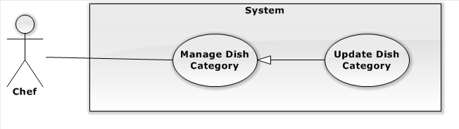

Figure 1-2: Update Dish Category Use Case

| **USE CASE SPECIFICATION** | | | |
| --- | --- | --- | --- |
| **Use-case No.** | UC001 | **Use-case Version** | 2.0 |
| **Use-case Name** | Update Dish Category | | |
| **Author** | Lê Quang Khương Duy | | |
| **Date** |  | **Priority** | High |
| **Actor:**  Chef  **Summary:**  Chef modifies existed Dish Category for EWC service.  **Goal:**  The purpose of Update Dish Category use case is allowed Chef to request for modifying existed Dish Category for the system.  **Triggers:**  Chef wants to modifies existed Dish Category in EWC service.  Chef clicks on “Danh mục Món Ăn” menu on menu bar.  Chef clicks on “Sửa” button in any Dish Category row of the table.  **Preconditions:**  User must be logged-in as Chef-role.  **Post Conditions:**  **Success:**   * Chef modifies existed Dish Category successful.   **Failure:**   * The Chef is presented an error message on screen.   **Main Success Scenario:**   |  |  | | --- | --- | | Actor Actions | System Response | | 1. Chef clicks on “Sửa” button. 2. Chef modifies Dish Category and clicks on “Lưu” button. [Alternative 1] | 1. The row of Dish Category turn to editting includes:   “Tên”[Name: Textbox, max length:100, require]  “Mô tả”[Description: text area, string]  “Hình ảnh” [Image: image picker, include a file input and a file-preview label]  “Hủy”[Button]  “Lưu”[Button]   1. Show message “Lưu thành công!”   [Exception 1] [Exception 2] [Exception 3] |   **Alternative Scenario:**   |  |  | | --- | --- | | Actor Actions | System Response | | Alternative 1   1. Chef clicks “Hủy” button. | 1. Cancel editting on new row and restore its information as the earlier. |     **Exceptions:**   |  |  | | --- | --- | | Actor Actions | System Response | | Exception 1   1. System fails to execute.   Exception 2   1. “Tên” field is empty   Exception 3   1. “Tên” field is existed in EWC system. | 1. Show message “Lưu thất bại. Xin thử lại sau”. 2. “Tên” field border turn to red and its placeholder is set to “Xin nhập tên”. 3. An error message appears next to “Tên” field with content “Tên này đã tồn tại”. |   **Relationships:**   * Manage Dish Category, Show Dish Category   **Business Rules:**   * N/A | | | |

3.2.2.2.4. Delete Dish Category

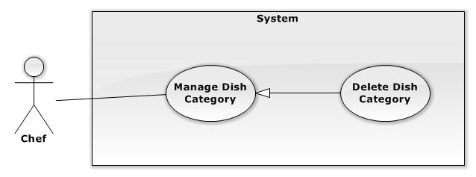

Figure 1-2: Update Dish Category Use Case

| **USE CASE SPECIFICATION** | | | |
| --- | --- | --- | --- |
| **Use-case No.** | UC001 | **Use-case Version** | 2.0 |
| **Use-case Name** | Delete Dish Category | | |
| **Author** | Lê Quang Khương Duy | | |
| **Date** |  | **Priority** | High |
| **Actor:**  Chef  **Summary:**  Chef deletes existed Dish Category for EWC service.  **Goal:**  The purpose of Update Dish Category use case is allowed Chef to request for deleting existed Dish Category for the system.  **Triggers:**  Chef wants to deletes existed Dish Category in EWC service.  Chef clicks on “Danh mục Món Ăn” menu on menu bar.  Chef clicks on “Xóa” button in any Dish Category row of the table.  **Preconditions:**  User must be logged-in as Chef-role.  **Post Conditions:**  **Success:**   * Chef deletes existed Dish Category successful.   **Failure:**   * The Chef is presented an error message on screen.   **Main Success Scenario:**   |  |  | | --- | --- | | Actor Actions | System Response | | 1. Chef clicks on “Xóa” button. 2. Chef clicks on “OK” button. [Alternative 1] | 1. Confirm message show up with warning “Bạn có thực sự muốn xóa Danh Mục này? Tất cả những Món Ăn trong Danh Mục cũng bị xóa!”   “OK”[Button]  “Cancel”[Button]   1. Show message “Lưu thành công!”   [Exception 1] [Exception 2] [Exception 3] |   **Alternative Scenario:**   |  |  | | --- | --- | | Actor Actions | System Response | | Alternative 1   1. Chef clicks “Hủy” button. | 1. Dismiss confirm message. |     **Exceptions:**   |  |  | | --- | --- | | Actor Actions | System Response | | Exception 1   1. System fails to execute. | 1. Show message “Lưu thất bại. Xin thử lại sau”. |   **Relationships:**   * Manage Dish Category, Show Dish Category   **Business Rules:**   * N/A | | | |

3.2.2.2. Manage Dish

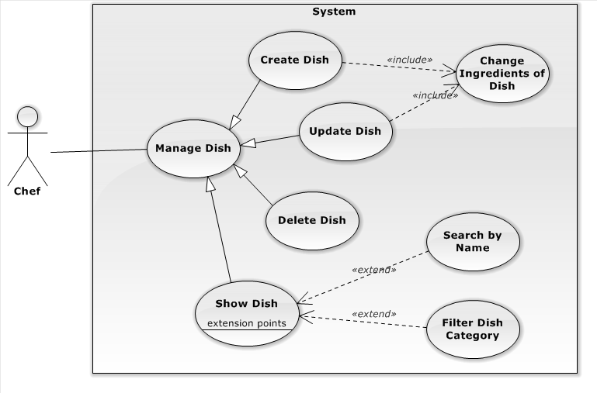

Figure 1-1: Manage Dish Use Case

3.2.2.2.1. Show Dish

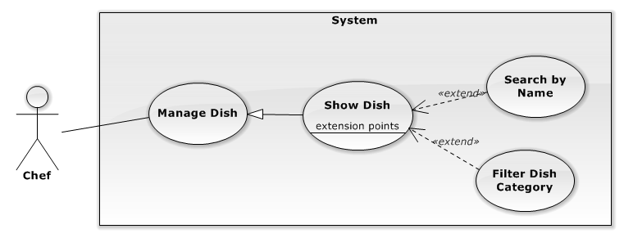

Figure 1-2: Show Dish Use Case

| **USE CASE SPECIFICATION** | | | |
| --- | --- | --- | --- |
| **Use-case No.** | UC001 | **Use-case Version** | 2.0 |
| **Use-case Name** | Show Dish | | |
| **Author** | Lê Quang Khương Duy | | |
| **Date** |  | **Priority** | High |
| **Actor:**  Chef  **Summary:**  Chef views all Dish in EWC service.  **Goal:**  The purpose of Show Dish use case is allowed Chef to request for viewing all Dish in the system.  **Triggers:**  Chef wants to view Dish for EWC service.  Chef clicks on “Món Ăn” menu on menu bar.  **Preconditions:**  User must be logged-in as Chef-role.  **Post Conditions:**  **Success:**   * Dishes are shown in Dish grid view of “Quản Lý Món Ăn” screen match with search conditions.   **Failure:**   * The Chef is presented with an error message on screen.   **Main Success Scenario:**   |  |  | | --- | --- | | Actor Actions | System Response | | 1. Chef clicks on “Món Ăn” menu on menu bar. 2. Chef choose filter options or type keyword for search. | 1. Redirect to “Quản Lý Món Ăn” page include:  * Search section: includes   “Tìm kiếm”[Keyword: TextBox, default is Empty]  Two filter for Dish Category[Dish Category Filter: Drop-down list, default is “Tất cả danh mục”] and sorting[Sort Filter: Drop-down list, default is “Tên: A đến Z”]  Paging control[Paging: list of Action Link, default is set at page 1].   * Dish Panel section: includes result Dishes for search conditions.  1. Dish Panel display list of suitable dishes for filter options. [Exception 1] | |  |  |   **Alternative Scenario:**   |  |  | | --- | --- | | Actor Actions | System Response | | N/A | N/A |     **Exceptions:**   |  |  | | --- | --- | | Actor Actions | System Response | | Exception 1   1. System fails to load data. | 1. Show message “Lỗi xảy ra. Xin thử lại.” |   **Relationships:**   * Manage Dish   **Business Rules:**   * N/A | | | |

3.2.2.2.2. Create Dish

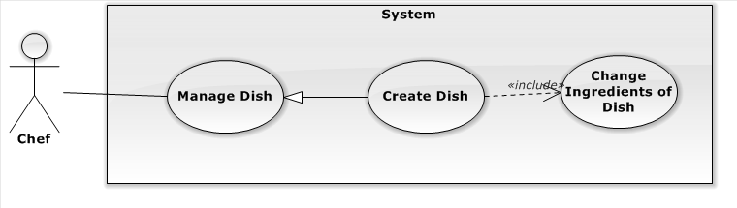

Figure 1-2: Create Dish Use Case

| **USE CASE SPECIFICATION** | | | |
| --- | --- | --- | --- |
| **Use-case No.** | UC001 | **Use-case Version** | 2.0 |
| **Use-case Name** | Create Dish | | |
| **Author** | Lê Quang Khương Duy | | |
| **Date** |  | **Priority** | High |
| **Actor:**  Chef  **Summary:**  Chef create new Dish  **Goal:**  The purpose of Create Dish use case is allowed Chef to request for creating new Dish in the system.  **Triggers:**  Chef wants to create Dish for EWC service.  Chef clicks on “Món Ăn” menu on menu bar to access “Quản Lý Món Ăn” page and then click “Tạo Mới” button.  **Preconditions:**  User must be logged-in as Chef-role.  **Post Conditions:**  **Success:**   * Chef creates new Dish successful.   **Failure:**   * The Chef is presented with an error message on screen.   **Main Success Scenario:**   |  |  | | --- | --- | | Actor Actions | System Response | | 1. Chef clicks on “Tạo Mới” button 2. Chef fills the information for the Dish and click “Tiếp tục” button or choose “Chọn nguyên liệu” tab. 3. Chef drags and drops Ingredient to the right container then clicks on “Thêm Mới” button.[Alternative 1] [Alternative 2] | 1. “Thêm Món Ăn” panel shows up on the center of the screen, includes:  * “Thông tin món ăn” tab:   “Tên”[Name: Textbox, max length: 100, require]  “Danh Mục”[Dish Category: Drop down list, includes all Dish Category]  “Giá”[Price: Textbox, require]  “Mô tả” [Description: text area, string]  “Cách nấu” [Cooking Guide: text area, string]  “Tag” [Tag: Textbox with multiple select, send request for searching existed Tag]  “Hình ảnh” [Image: image picker, include a file input and a file-preview label]  “Tiếp tục”[Button]   * “Chọn nguyên liệu” tab:   Ingredient container at the left contains available Ingredients include search input [Keyword, Textbox, max length: 100] and Ingredient Category filter [Ingredient Category, Drop down list, includes all Ingredient Category].  Selected Ingredient container at the right contains Ingredients that Chef chose.  “Trở lại”[Button]  “Thêm mới”[Button]   1. Switch to “Chọn nguyên liệu” tab.   [Exception 1] [Exception 2] [Exception 3]  [Exception 4] [Exception 5]   1. Shows message “Thao tác thành công!” to Chef. |   **Alternative Scenario:**   |  |  | | --- | --- | | Actor Actions | System Response | | [Alternative 1]   1. Chef clicks on “Trở lại” button or choose “Thông tin món ăn” tab.   [Alternative 2]   1. Chef types in Keyword textbox. | 1. Switch back to “Thông tin món ăn” tab. 2. Show Ingredient container with suitable filter conditions. |     **Exceptions:**   |  |  | | --- | --- | | Actor Actions | System Response | | [Exception 1]   1. “Tên” field is empty.   [Exception 2]   1. “Tên” field content is existed.   [Exception 3]   1. “Giá” field content is not a integer.   [Exception 4]   1. Selected Ingredient container is empty.   [Exception 5]   1. System fails to execute. | 1. Switch back to “Thông tin món ăn” tab and “Tên” field border turn red with placeholder is “Tên món ăn không được TRỐNG!”. 2. Switch back to “Thông tin món ăn” tab and shows error “Tên món ăn không được TRỐNG!” next to “Tên” field. 3. Switch back to “Thông tin món ăn” tab and “Giá” field border turn red with placeholder is “Số dương!”. 4. Message “Kéo thả nguyên liệu vào khung bên đây” fade in, fade out 3 times. 5. Show error message “Lỗi xảy ra. Xin thử lại sau!” . |   **Relationships:**  Manage Dish, Show Dish  **Business Rules:**   * N/A | | | |

* + - * 1. Update Dish

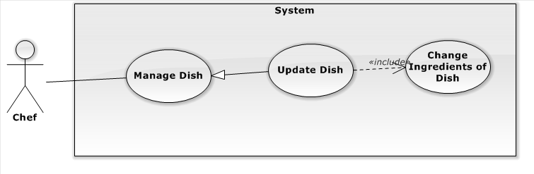

Figure 1-2: Update Dish Use Case

| **USE CASE SPECIFICATION** | | | |
| --- | --- | --- | --- |
| **Use-case No.** | UC001 | **Use-case Version** | 2.0 |
| **Use-case Name** | Update Dish | | |
| **Author** | Lê Quang Khương Duy | | |
| **Date** |  | **Priority** | High |
| **Actor:**  Chef  **Summary:**  Chef modifies existed Dish information.  **Goal:**  The purpose of Update Dish use case is allowed Chef to request for modifying existed Dish in the system.  **Triggers:**  Chef wants to modify Dish for EWC service.  Chef clicks on any Dish in “Quản Lý Món Ăn” page.  **Preconditions:**  User must be logged-in as Chef-role.  **Post Conditions:**  **Success:**   * Chef modifies existed Dish successful.   **Failure:**   * The Chef is presented with an error message on screen.   **Main Success Scenario:**   |  |  | | --- | --- | | Actor Actions | System Response | | 1. Chef clicks on a Dish in “Quản Lý Món Ăn” page. 2. Chef modifies the information for the Dish and click “Tiếp tục” button or choose “Chọn nguyên liệu” tab. 3. Chef drags and drops Ingredient to the right container then clicks on “Thêm Mới” button.[Alternative 1] [Alternative 2] | 1. “Sửa Thông Tin Món Ăn” panel shows up on the center of the screen with information of the selected Dish, includes:  * “Thông tin món ăn” tab:   “Tên”[Name: Textbox, max length: 100, require]  “Danh Mục”[Dish Category: Drop down list, includes all Dish Category]  “Giá”[Price: Textbox, require]  “Mô tả” [Description: text area, string]  “Cách nấu” [Cooking Guide: text area, string]  “Tag” [Tag: Textbox with multiple select, send request for searching existed Tag]  “Hình ảnh” [Image: image picker, include a file input and a file-preview label]  “Tiếp tục”[Button]   * “Chọn nguyên liệu” tab:   Ingredient container at the left contains available Ingredients include search input [Keyword, Textbox, max length: 100] and Ingredient Category filter [Ingredient Category, Drop down list, includes all Ingredient Category].  Selected Ingredient container at the right contains Ingredients that Chef chose.  “Trở lại”[Button]  “Chỉnh sửa”[Button]   1. Switch to “Chọn nguyên liệu” tab.   [Exception 1] [Exception 2] [Exception 3]  [Exception 4]   1. Shows message “Thao tác thành công!” to Chef. |   **Alternative Scenario:**   |  |  | | --- | --- | | Actor Actions | System Response | | [Alternative 1]   1. Chef clicks on “Trở lại” button or choose “Thông tin món ăn” tab.   [Alternative 2]   1. Chef types in Keyword textbox. | 1. Switch back to “Thông tin món ăn” tab. 2. Show Ingredient container with suitable filter conditions. |     **Exceptions:**   |  |  | | --- | --- | | Actor Actions | System Response | | [Exception 1]   1. “Tên” field is empty.   [Exception 2]   1. “Tên” field content is existed.   [Exception 3]   1. “Giá” field content is not a integer.   [Exception 4]   1. Selected Ingredient container is empty.   [Exception 5]   1. System fails to execute. | 1. Switch back to “Thông tin món ăn” tab and “Tên” field border turn red with placeholder is “Tên món ăn không được TRỐNG!”. 2. Switch back to “Thông tin món ăn” tab and shows error “Tên món ăn không được TRỐNG!” next to “Tên” field. 3. Switch back to “Thông tin món ăn” tab and “Giá” field border turn red with placeholder is “Số dương!”. 4. Message “Kéo thả nguyên liệu vào khung bên đây” fade in, fade out 3 times. 5. Show error message “Lỗi xảy ra. Xin thử lại sau!” . |   **Relationships:**  Manage Dish, Show Dish  **Business Rules:**   * N/A | | | |

* + - * 1. Delete Dish

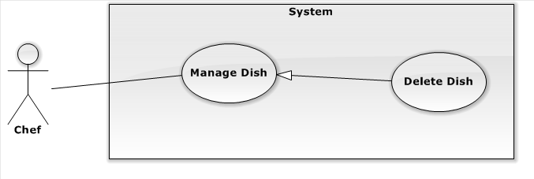

Figure 1-2: Delete Dish Use Case

| **USE CASE SPECIFICATION** | | | |
| --- | --- | --- | --- |
| **Use-case No.** | UC001 | **Use-case Version** | 2.0 |
| **Use-case Name** | Delete Dish | | |
| **Author** | Lê Quang Khương Duy | | |
| **Date** |  | **Priority** | High |
| **Actor:**  Chef  **Summary:**  Chef deletes existed Dish information.  **Goal:**  The purpose of Delete Dish use case is allowed Chef to request for deleting existed Dish in the system.  **Triggers:**  Chef wants to delete Dish for EWC service.  Chef clicks on “Xóa” button in “Sửa thông tin Món Ăn” panel of a Dish.  **Preconditions:**  User must be logged-in as Chef-role.  **Post Conditions:**  **Success:**   * Chef deletes existed Dish successful.   **Failure:**   * The Chef is presented with an error message on screen.   **Main Success Scenario:**   |  |  | | --- | --- | | Actor Actions | System Response | | 1. Chef clicks on “Xóa” button in “Sửa thông tin Món Ăn” panel of a Dish. 2. Chef clicks “OK” button.   [Alternative 1] | 1. Confirm message show up with warning “Bạn có thực sự muốn xóa Món Ăn này?”   “OK”[Button]  “Cancel”[Button]   1. Show message “Thao tác thành công!”.[Exception 1] |   **Alternative Scenario:**   |  |  | | --- | --- | | Actor Actions | System Response | | [Alternative 1]   1. Chef clicks on “Cancel” button. | 1. Dismiss confirm message. |     **Exceptions:**   |  |  | | --- | --- | | Actor Actions | System Response | | [Exception 1]   1. System fails to execute. | 1. Show error message “Lỗi xảy ra. Xin thử lại sau!”. |   **Relationships:**  Manage Dish, Show Dish, Update Dish.  **Business Rules:**   * N/A | | | |

3.2.2.3. Manage Produce Session

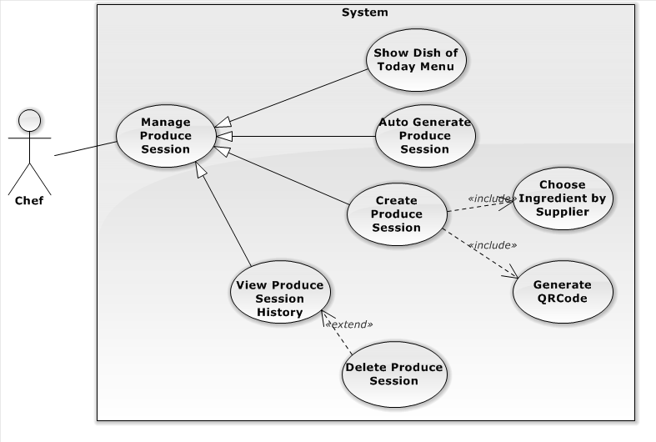

Figure 1-1: Manage Produce Session Use Case

3.2.2.3.1. Show Dish of Today Menu

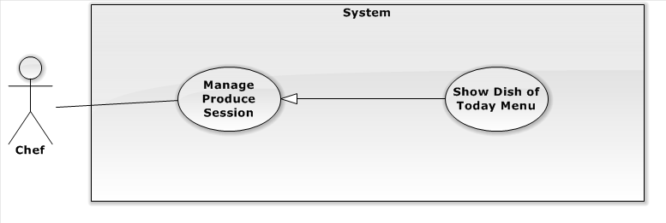

Figure 1-2: Show Dish of Today Menu Use Case

| **USE CASE SPECIFICATION** | | | |
| --- | --- | --- | --- |
| **Use-case No.** | UC001 | **Use-case Version** | 2.0 |
| **Use-case Name** | Show Dish of Today Menu | | |
| **Author** | Lê Quang Khương Duy | | |
| **Date** |  | **Priority** | High |
| **Actor:**  Chef  **Summary:**  Chef views all Dish of Today Menu in EWC service.  **Goal:**  The purpose of Show Dish of Today Menu use case is allowed Chef to request for viewing all Dish of Today Menu in the system.  **Triggers:**  Chef wants to view Dish of Today Menu in EWC service.  Chef clicks on “Phiên Chế Biến” menu on menu bar.  **Preconditions:**  User must be logged-in as Chef-role.  **Post Conditions:**  **Success:**   * Dish of Today Menu are shown in table of “Quản Lý Phiên Chế Biến” screen match with search conditions.   **Failure:**   * The Chef is guided to Error page.   **Main Success Scenario:**   |  |  | | --- | --- | | Actor Actions | System Response | | 1. Chef clicks on “Phiên Chế Biến” menu on menu bar. 2. Chef choose filter options or type keyword for search. | 1. Redirect to “Quản Lý Phiên Chế Biến” page contains list Dish of Today Menu includes:   Rows as “Món Ăn”, “Hình Ảnh”, “Số lượng đã được nấu”, “Số lượng đã đặt hàng” and “Chế Biến”[Button]  [Records per page, Drop down list includes 5, 10, 15, All, default is 5]  “Search”[Search Dish Category, Textbox]  Paging control[Paging: list of Action Link, default is set at page 1].  [Exception 1][Exception 2]   1. Show list of Dish match with search conditions. |   **Alternative Scenario:**   |  |  | | --- | --- | | Actor Actions | System Response | | N/A | N/A |     **Exceptions:**   |  |  | | --- | --- | | Actor Actions | System Response | | Exception 1   1. System fails to load data.   Exception 2   1. Today Menu is not repaired or no Dish in the Menu. | 1. Show Error page. 2. Show message “Rất tiếc! Menu của ngày hôm nay chưa được chuẩn bị. Xin chuẩn bị và quay lại sau!”. |   **Relationships:**   * Manage Produce Session   **Business Rules:**   * In order to create Produce Session, today Menu must have been repaired. | | | |

3.2.2.3.2. Auto Generate Produce Session

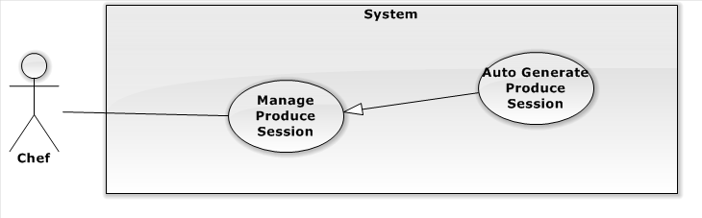

Figure 1-2: Auto Generate Produce Session Use Case

| **USE CASE SPECIFICATION** | | | |
| --- | --- | --- | --- |
| **Use-case No.** | UC001 | **Use-case Version** | 2.0 |
| **Use-case Name** | Auto Generate Produce Session | | |
| **Author** | Lê Quang Khương Duy | | |
| **Date** |  | **Priority** | High |
| **Actor:**  Chef  **Summary:**  System generates Produce Session base on customer order for today Menu.  **Goal:**  The purpose of Auto Generate Produce Session use case is allowed Chef to request  for generates Produce Session base on customer order for today Menu automatically.  **Triggers:**  Chef wants to generates Produce Session base on customer order for today Menu automatically.  Chef clicks on “Phiên Chế Biến” menu on menu bar.  Chef clicks on “Phát sinh tự động” button.  **Preconditions:**  User must be logged-in as Chef-role.  **Post Conditions:**  **Success:**   * Produce Sessions are generated successfully.   **Failure:**   * The Chef is presented with an error message on screen.   **Main Success Scenario:**   |  |  | | --- | --- | | Actor Actions | System Response | | 1. Chef clicks on “Phát sinh tự động” button. 2. Chef clicks on “OK” button.   [Alternative 1] | 1. Show up confirm message “Bạn có muốn tự động tạo Phiên Chế Biến?”.   “OK”[Button]  “Cancel”[Button]   1. Refresh page and display message “Tự động Phát sinh Phiên Chế Biến thành công.” [Exception 1] |   **Alternative Scenario:**   |  |  | | --- | --- | | Actor Actions | System Response | | [Alternative 1]   1. Chef clicks on “Cancel” button. | 1. Dismiss confirm message. |     **Exceptions:**   |  |  | | --- | --- | | Actor Actions | System Response | | [Exception 1]   1. System fails to execute. | 1. Show error page. |   **Relationships:**   * Manage Produce Session, Show Dish of Today Menu   **Business Rules:**   * N/A | | | |

3.2.2.3.3. Create Produce Session

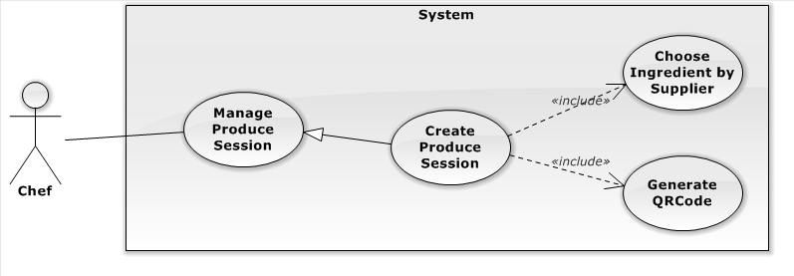

Figure 1-2: Create Produce Session Use Case

| **USE CASE SPECIFICATION** | | | |
| --- | --- | --- | --- |
| **Use-case No.** | UC001 | **Use-case Version** | 2.0 |
| **Use-case Name** | Create Produce Session | | |
| **Author** | Lê Quang Khương Duy | | |
| **Date** |  | **Priority** | High |
| **Actor:**  Chef  **Summary:**  Chef create new Produce Session  **Goal:**  The purpose of Create Produce Session use case is allowed Chef to request for creating new Produce Session in the system.  **Triggers:**  Chef wants to create Produce Session for EWC service.  Chef clicks on “Phiên Chế Biến” menu on menu bar to access “Quản Lý Phiên Chế Biến” page and then click C:\Users\Lubu\Desktop\Untitled.png “Chế biến” button.  **Preconditions:**  User must be logged-in as Chef-role.  **Post Conditions:**  **Success:**   * Chef creates new Produce Session successful.   **Failure:**   * The Chef is presented with an error message on screen.   **Main Success Scenario:**   |  |  | | --- | --- | | Actor Actions | System Response | | 1. Chef clicks C:\Users\Lubu\Desktop\Untitled.png “Chế biến” button. 2. Chef fills in “Số lượng” and select Supplier for each Ingredient and then click “Chế biến”. [Alternative 1] 3. Chef click on x button of “Phát sinh QRCode” panel or click outside. [Alternative 2] | 1. “Tạo Phiên Chế Biến” panel shows up on the center of the screen, includes:   “Món Ăn”[Name: Textbox, max length: 100, readonly]  “Hình ảnh” [Image]  “Số lượng” [“Quantity: Textbox, max length: 3, require]  “Nguyên liệu” [list of multi-select input for each Ingredient of the Dish]  “Khôi phục mặc định” [Button]  “Chế biến”[Button]   1. “Phát sinh QRCode” panel show up includes: Dish Name, Quantity and “Nhấn Vào Đây” button in case that chef want to re-download QRCode image.[Exception 1] 2. “Phát sinh QRCode” panel dismiss and page is refreshed. [Exception 2] |   **Alternative Scenario:**   |  |  | | --- | --- | | Actor Actions | System Response | | [Alternative 1]   1. Chef clicks on “Khôi phục mặc định” button.   [Alternative 2]   1. Chef clicks on “Bỏ Qua” button. | 1. “Số lượng” is set to 5 and default Supplier for each Ingredient are used. 2. Force dismiss “Phát sinh QRCode” panel whatever QRCode image is downloaded or not. |     **Exceptions:**   |  |  | | --- | --- | | Actor Actions | System Response | | [Exception 1]   1. System fails to execute.   [Exception 2]   1. QRCode image is not downloaded. | 1. Show error message “Lỗi xảy ra. Xin thử lại sau!”. 2. “Phát sinh QRCode” panel re-open then show message “Mã QRCode cho sản phẩm vẫn chưa được tải xuống!” and a download link “Nhấn vào đây” |   **Relationships:**  Manage Produce Session, Show Dish of Today Menu  **Business Rules:**   * N/A | | | |

3.2.2.3.3. View Produce Session History

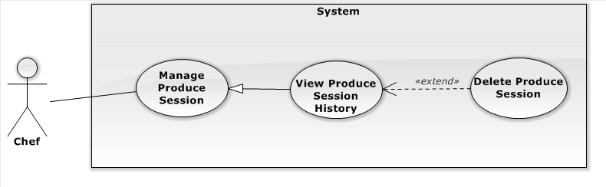

Figure 1-2: View Produce Session History Use Case

| **USE CASE SPECIFICATION** | | | |
| --- | --- | --- | --- |
| **Use-case No.** | UC001 | **Use-case Version** | 2.0 |
| **Use-case Name** | View Produce Session History | | |
| **Author** | Lê Quang Khương Duy | | |
| **Date** |  | **Priority** | High |
| **Actor:**  Chef  **Summary:**  Chef view Produce Session History  **Goal:**  The purpose of View Produce Session History use case is allowed Chef to request for viewing Produce Session History in the system.  **Triggers:**  Chef wants to view Produce Session History in EWC service.  Chef clicks on “Phiên Chế Biến” menu on menu bar to access “Quản Lý Phiên Chế Biến” page and then click “Lịch sử Phiên Chế Biến” button.  **Preconditions:**  User must be logged-in as Chef-role.  **Post Conditions:**  **Success:**   * Produce Session are shown in table of “Lịch sử Phiên Chế Biến” screen match with search conditions.   **Failure:**   * The Chef is presented with an error message on screen.   **Main Success Scenario:**   |  |  | | --- | --- | | Actor Actions | System Response | | 1. Chef clicks on “Lịch sử Phiên Chế Biến” button. 2. Chef choose filter options or type keyword for search.   [Alternative 1] [Alternative 2] | 1. Show up “Lịch sử Phiên Chế Biến” page contains list of Produce Session includes:   [Records per page, Drop down list includes 10, 25, 50, 100, All, default is 10]  “Chọn ngày”[Date, Date Picker, default is set today]  “Search”[Search Produce Session, Textbox]  Paging control[Paging: list of Action Link, default is set at page 1].  [Exception 1]   1. Show list of Dish Category match with search conditions. [Exception 2] |   **Alternative Scenario:**   |  |  | | --- | --- | | Actor Actions | System Response | | Alternative 1   1. Chef clicks on “Tải xuống” button in the specific row of Produce Session.   Alternative 2   1. Chef clicks on C:\Users\Lubu\Desktop\Untitled.png “Xóa” button in the specific row of Produce Session. 2. Chef clicks “OK” button.   [Alternative 3]  Alternative 3   1. Chef clicks on “Cancel” button. | 1. Re-download QRCode for the Dish of Produce Session. 2. Show confirm message “Bạn có thực sự muốn xóa Phiến Chế Biến này không?”.   “OK”[Button]  “Cancel”[Button]   1. Remove row contains deleted Produce Session.[Exception 2][Exception 3] 2. Dismiss confirm message. |     **Exceptions:**   |  |  | | --- | --- | | Actor Actions | System Response | | Exception 1   1. System fails to load data.   Exception 2   1. Dish of this Produce Session has been delivered.   Exception 3   1. System fails to execute. | 1. Show error message “Lỗi hệ thống! Xin thử lại sau.” 2. Show message “Do sản phẩm này đã được giao hàng nên không thể xóa!” 3. Show error message “Lỗi hệ thống! Xin thử lại sau.” |   **Relationships:**   * Manage Produce Session   **Business Rules:**   * Cannot delete delivered Produce Session. | | | |

* + - 1. User Interfaces
         1. Show Dish Category

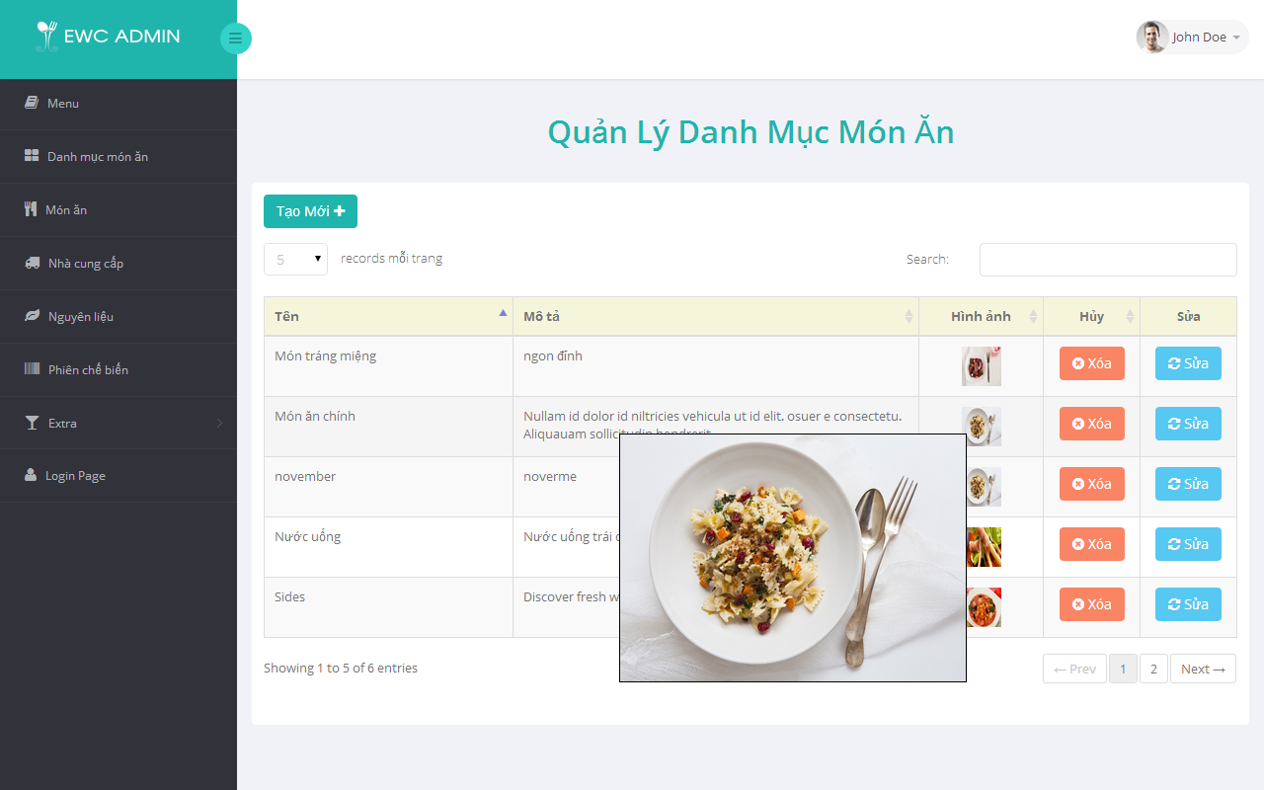

(1)

(2)

(3)

(5)

(4)

(6)

(7)

(8)

Figure 5.11: Show Dish Category screen

|  |  |  |  |
| --- | --- | --- | --- |
| **No.** | **Name** | **Type** | **Description** |
| **1** | “Tạo Mới” | Button | Create new Dish Category |
| **2** | Records per page | Drop down list | Number of Dish Category display per page of table |
| **3** | “Search” | Textbox | Search by Name and Description |
| **4** | Paging | Buttons | Select page want to view |
| **5** | List of Dish Category | Table | Contains list of Dish Category match with search conditions |
| **6** | Image | Image | Bigger image of Dish Category show up when user hover the smaller one |
| **7** | “Xóa” | Button | Delete Dish Category of the chose row |
| **8** | “Sửa” | Button | Modify Dish Category of the chose row |

Table 5-1: Show Dish Category screen description

* + - * 1. Show Dish Category

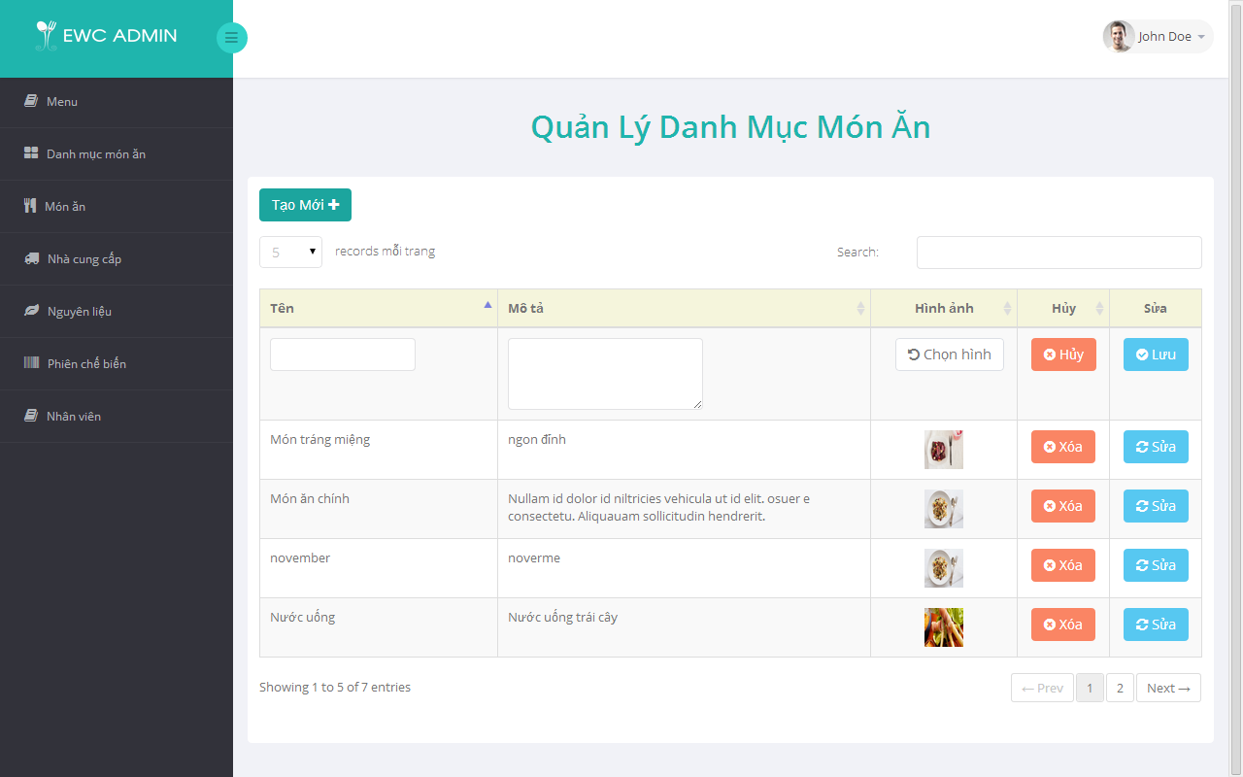

(1)

(2)

(3)

(5)

(4)

(9)

(10)

(6)

(7)

(8)

Figure 5.11: Create Dish Category screen

|  |  |  |  |
| --- | --- | --- | --- |
| **No.** | **Name** | **Type** | **Description** |
| **1** | “Tạo Mới” | Button | Create new Dish Category |
| **2** | Records per page | Drop down list | Number of Dish Category display per page of table |
| **3** | “Search” | Textbox | Search by Name and Description |
| **4** | Paging | Buttons | Select page want to view |
| **5** | List of Dish Category | Table | Contains list of Dish Category match with search conditions |
| **6** | “Tên” | Textbox | Input field for Dish Category Name |
| **7** | “Mô tả” | Text area | Input field for Dish Category Description |
| **8** | “Hình ảnh” | Image Picker | Choose Dish Category Image |
| **9** | “Hủy” | Button | Cancel editting and delete current editting row |
| **10** | “Lưu” | Button | Create and save editting Dish Category |

Table 5-1: Create Dish Category screen description

* + - * 1. Update Dish Category

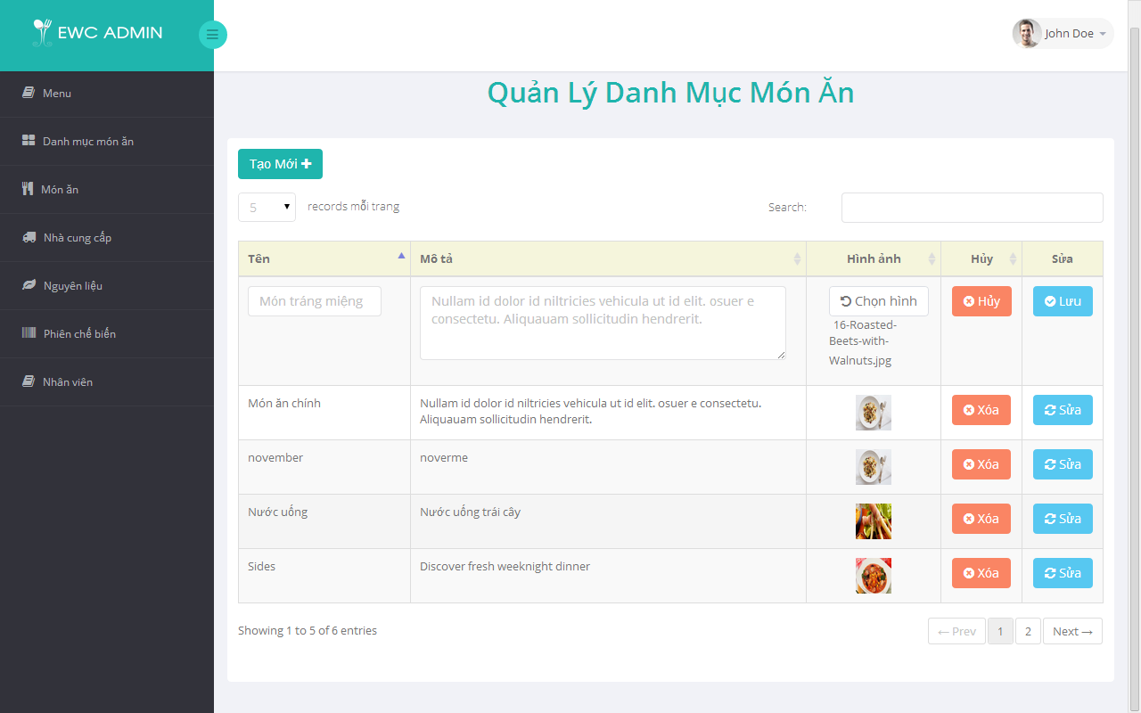

(1)

(2)

(3)

(5)

(4)

(9)

(10)

(6)

(7)

(8)

Figure 5.11: Update Dish Category screen

|  |  |  |  |
| --- | --- | --- | --- |
| **No.** | **Name** | **Type** | **Description** |
| **1** | “Tạo Mới” | Button | Create new Dish Category |
| **2** | Records per page | Drop down list | Number of Dish Category display per page of table |
| **3** | “Search” | Textbox | Search by Name and Description |
| **4** | Paging | Buttons | Select page want to view |
| **5** | List of Dish Category | Table | Contains list of Dish Category match with search conditions |
| **6** | “Tên” | Textbox | Input field for Dish Category Name |
| **7** | “Mô tả” | Text area | Input field for Dish Category Description |
| **8** | “Hình ảnh” | Image Picker | Choose Dish Category Image with file name preview |
| **9** | “Hủy” | Button | Cancel editting and restore current editting row |
| **10** | “Lưu” | Button | Save editting Dish Category |

Table 5-1: Update Dish Category screen description

* + - * 1. Delete Dish Category

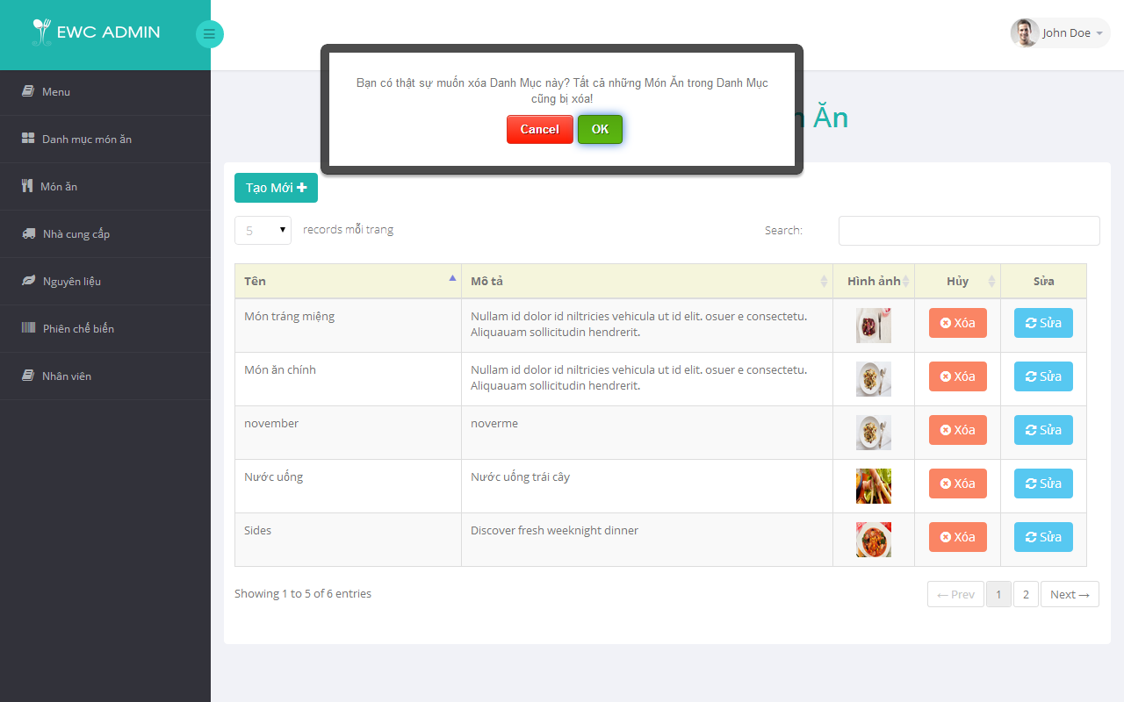

(1)

(5)

(4)

(2)

(3)

Figure 5.11: Delete Dish Category screen

|  |  |  |  |
| --- | --- | --- | --- |
| **No.** | **Name** | **Type** | **Description** |
| **1** | List of Dish Category | Table | Contains list of Dish Category match with search conditions |
| **2** | “Xóa” | Button | Delete the matched Dish Category with chose row |
| **3** | Confirm deleting | Panel | Confirm that user really want to delete Dish Category |
| **4** | “OK” | Button | Delete selected Dish Category |
| **5** | “Cancel” | Button | Cancel deleting and dismiss confirm panel |

Table 5-1: Delete Dish Category screen description

* + - * 1. Show Dish

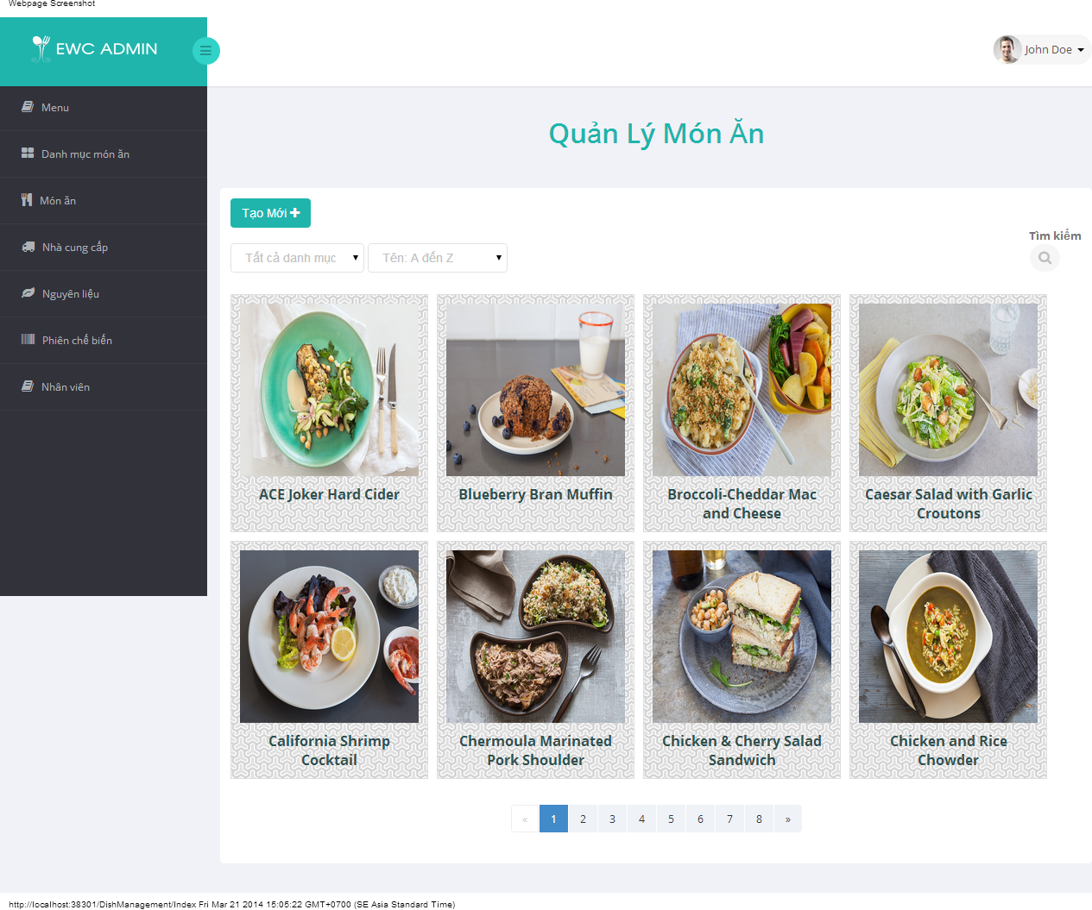

(1)

(6)

(4)

(2)

(3)

(5)

Figure 5.11: Show Dish screen

|  |  |  |  |
| --- | --- | --- | --- |
| **No.** | **Name** | **Type** | **Description** |
| **1** | “Tạo Mới” | Button | Create new Dish. |
| **2** | “Tìm Kiếm” | Textbox | Search Dish by Name |
| **3** | Filter Dish Category | Drop down list | Contains all Dish Category in EWC. Choose one to fillter all Dish in selected Dish Category |
| **4** | Sort | Drop down list | Sort list of Dish by Name, Price |
| **5** | Paging | Buttons | Go to selected page of Dish |
| **6** | List of Dish | Gridview | Contains Dishes that match filter conditions. |

Table 5-1: Show Dish screen description

* + - * 1. Create Dish

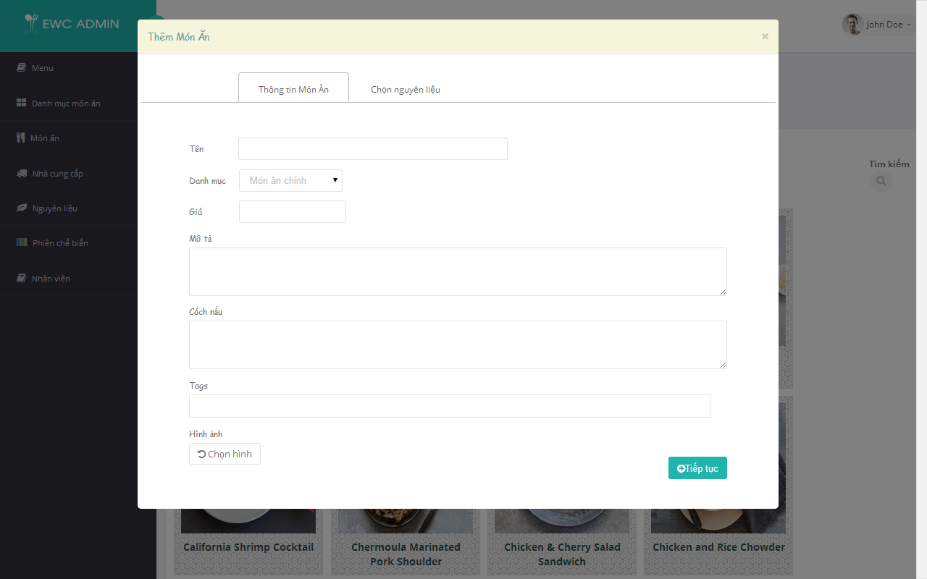

(1)

(2)

(3)

(4)

(5)

(6)

(7)

(8)

Figure 5.11: Create Dish Information screen

|  |  |  |  |
| --- | --- | --- | --- |
| **No.** | **Name** | **Type** | **Description** |
| **1** | “Tên” | Textbox | Dish Name |
| **2** | “Danh Mục” | Drop down list | Dish Category |
| **3** | “Giá” | Textbox | Dish Price |
| **4** | “Mô tả” | Text area | Dish Description |
| **5** | “Cách nấu” | Text area | Cooking Guide for Dish |
| **6** | ”Tags” | Textbox | Tags for Dish |
| **7** | “Hình ảnh” | Image Picker | Dish Image |
| **8** | “Tiếp tục” | Button | Go to “Chọn nguyên liệu” tab |

Table 5-1: Create Dish Information screen description

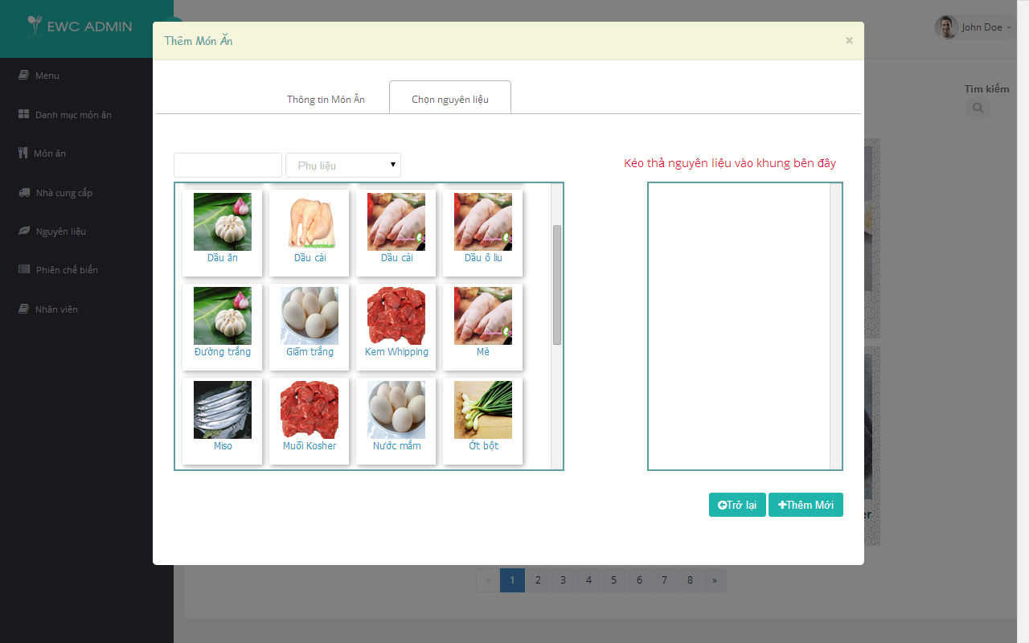

(1)

(2)

(3)

(4)

(5)

(6)

Figure 5.11: Choose Ingredients for Dish screen

|  |  |  |  |
| --- | --- | --- | --- |
| **No.** | **Name** | **Type** | **Description** |
| **1** | Search | Textbox | Search for Ingredient by Name |
| **2** | Ingredient Category Filter | Drop down list | Display just Ingredients belongs to selected Ingredient Category |
| **3** | List of Ingredients | Gridview | Ingredients that match filter conditions. |
| **4** | Selected Ingredients Container | Gridview | Contains Ingredients that user choose |
| **5** | “Trở lại” | Button | Switch back to “Thông tin món ăn” tab |
| **6** | “Thêm mới” | Button | Save new Dish with user input information |

Table 5-1: Choose Ingredients for Dish screen description

* + - * 1. Update Dish

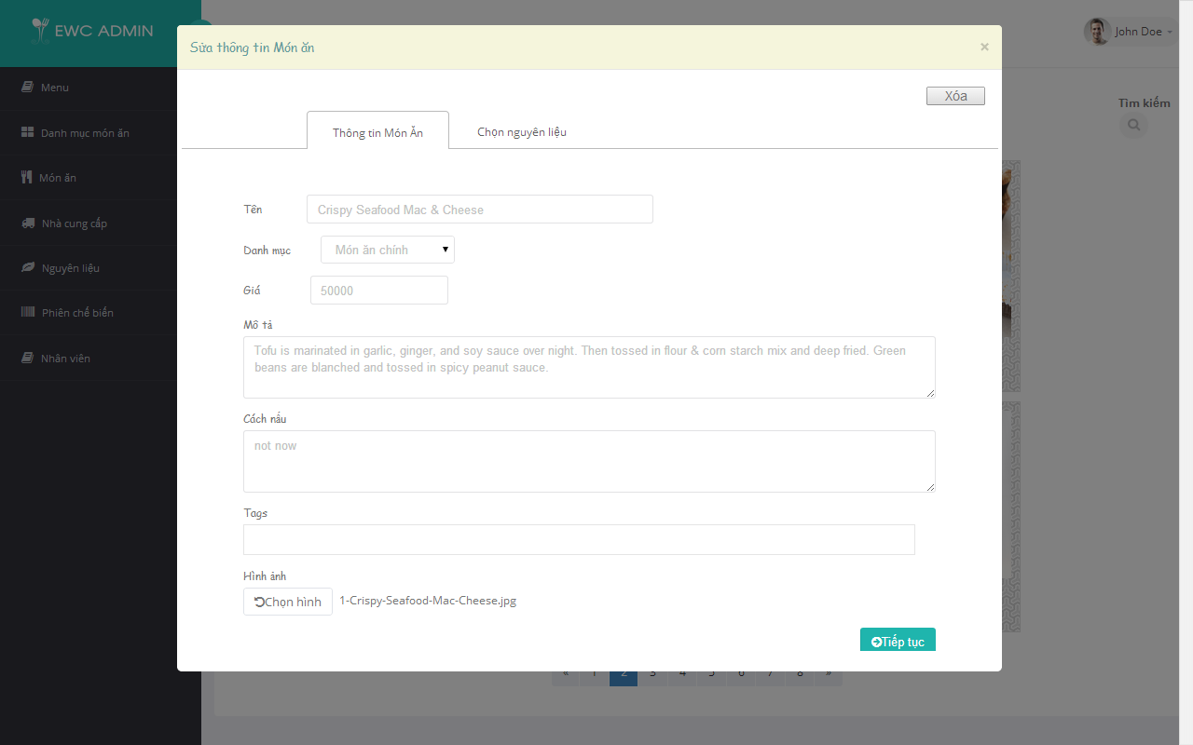

(1)

(2)

(3)

(4)

(5)

(6)

(7)

(8)

Figure 5.11: Update Dish Information screen

|  |  |  |  |
| --- | --- | --- | --- |
| **No.** | **Name** | **Type** | **Description** |
| **1** | “Tên” | Textbox | Dish Name |
| **2** | “Danh Mục” | Drop down list | Dish Category |
| **3** | “Giá” | Textbox | Dish Price |
| **4** | “Mô tả” | Text area | Dish Description |
| **5** | “Cách nấu” | Text area | Cooking Guide for Dish |
| **6** | ”Tags” | Textbox | Tags for Dish |
| **7** | “Hình ảnh” | Image Picker | Dish Image with Filename Preview |
| **8** | “Tiếp tục” | Button | Go to “Chọn nguyên liệu” tab |

Table 5-1: Update Dish Information screen description

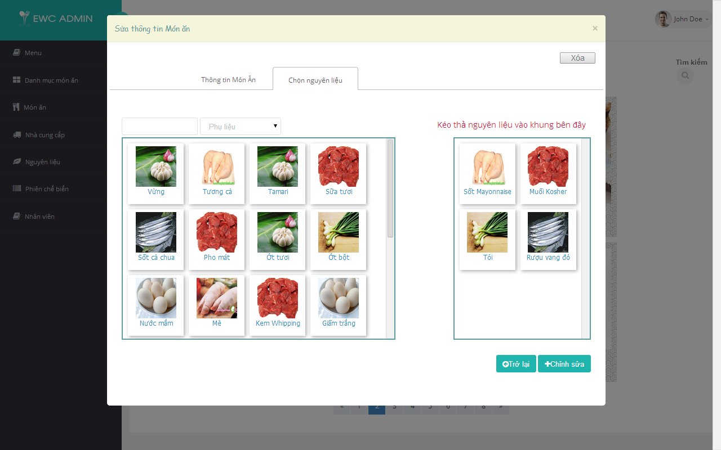

(1)

(2)

(3)

(4)

(5)

(6)

Figure 5.11: Choose Ingredients for Dish screen

|  |  |  |  |
| --- | --- | --- | --- |
| **No.** | **Name** | **Type** | **Description** |
| **1** | Search | Textbox | Search for Ingredient by Name |
| **2** | Ingredient Category Filter | Drop down list | Display just Ingredients belongs to selected Ingredient Category |
| **3** | List of Ingredients | Gridview | Ingredients that match filter conditions. |
| **4** | Selected Ingredients Container | Gridview | Contains Ingredients that user choose |
| **5** | “Trở lại” | Button | Switch back to “Thông tin món ăn” tab |
| **6** | “Thêm mới” | Button | Save new Dish with user input information |

Table 5-1: Choose Ingredients for Dish screen description

* + - * 1. Delete Dish

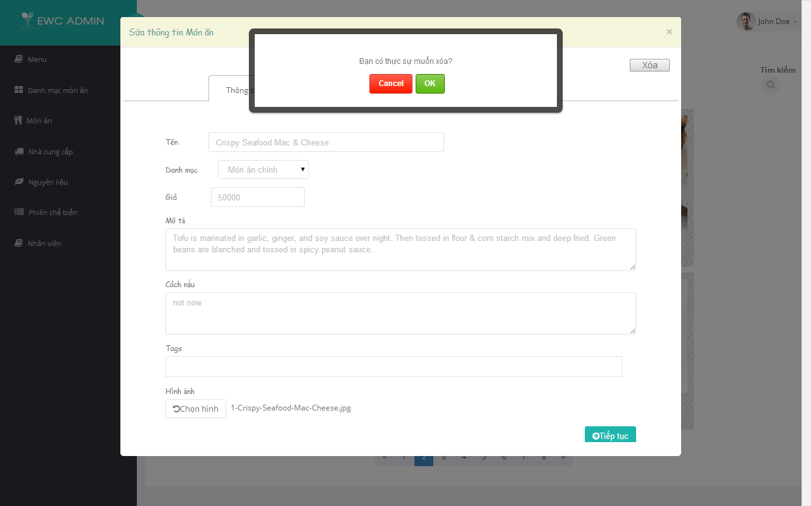

(4)

(3)

(1)

(2)

Figure 5.11: Delete Dish Category screen

|  |  |  |  |
| --- | --- | --- | --- |
| **No.** | **Name** | **Type** | **Description** |
| **1** | “Xóa” | Button | Delete the matched Dish with chose row |
| **2** | Confirm deleting | Panel | Confirm that user really want to delete Dish |
| **3** | “OK” | Button | Delete selected Dish |
| **4** | “Cancel” | Button | Cancel deleting and dismiss confirm panel |

Table 5-1: Delete Dish screen description

* + - * 1. Show Dish of Today Menu

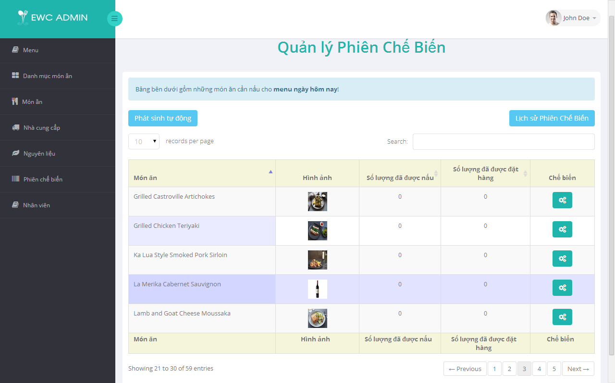

(1)

(6)

(4)

(2)

(3)

(5)

(7)

Figure 5.11: Show Dish of Today Menu screen

|  |  |  |  |
| --- | --- | --- | --- |
| **No.** | **Name** | **Type** | **Description** |
| **1** | “Phát sinh tự động” | Button | Generate Produce Session automatically base on customer order |
| **2** | “Lịch sử Phiên Chế Biến” | Button | View Produce Session history by date |
| **3** | Records per page | Drop down list | Number of Dish display per page of table |
| **4** | “Search” | Textbox | Search by Dish Name |
| **5** | Paging | Buttons | Go to selected page of Dish |
| **6** | List of Dish for Today Menu | Gridview | Contains Dishes of today Menu that match filter conditions. |

Table 5-1: Show Dish of Today Menu screen description

* + - * 1. Auto Generate Produce Session

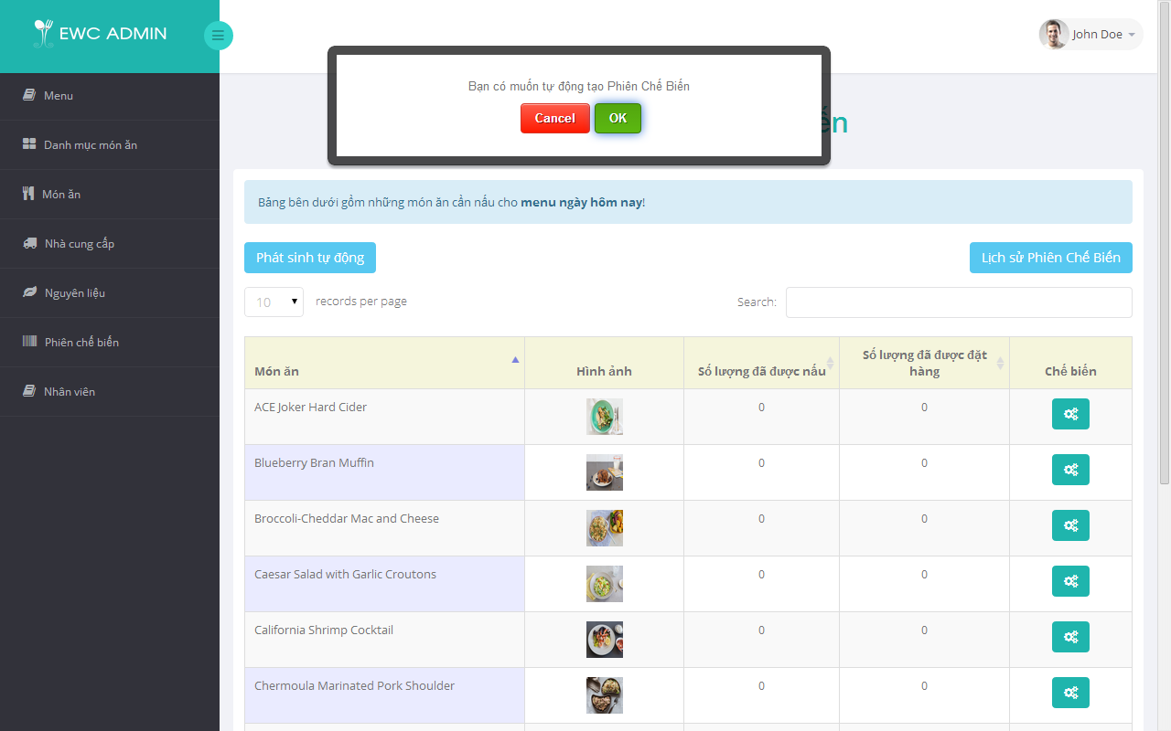

(4)

(3)

(1)

(2)

Figure 5.11: Auto Generate Produce Session screen

|  |  |  |  |
| --- | --- | --- | --- |
| **No.** | **Name** | **Type** | **Description** |
| **1** | “Phát sinh tự động” | Button | Generate Produce Session automatically base on customer order |
| **2** | Confirm panel | Panel | Confirm that user really want to generate Produce Session |
| **3** | “OK” | Button | System create list of Produce Session automatically base on customer order |
| **4** | “Cancel” | Button | Cancel process and dismiss confirm panel |

Table 5-1: Auto Generate Produce Session screen description

* + - * 1. Create Produce Session

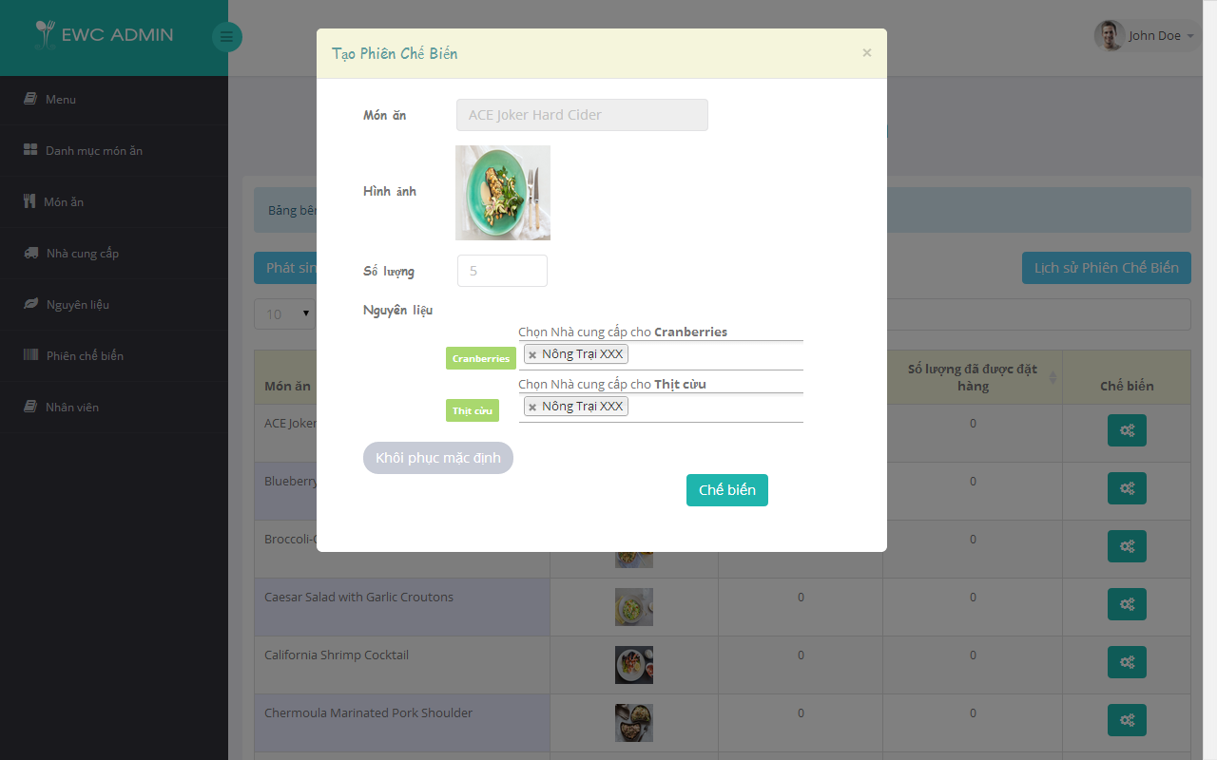

(4)

(3)

(1)

(2)

(6)

(5)

Figure 5.11: Create Session screen

|  |  |  |  |
| --- | --- | --- | --- |
| **No.** | **Name** | **Type** | **Description** |
| **1** | “Món Ăn” | Textbox (readonly) | Dish Name that need to be produced |
| **2** | “Hình ảnh” | Image | Dish Image |
| **3** | “Số lượng” | Textbox (Integer) | Produce quantity |
| **4** | “Nguyên liệu” | Multi-selectors | Contains all Ingredients need to produce current Dish. Click to choose Suppliers for that Ingredient |
| **5** | “Khôi phục mặc định” | Button | Restore “Số lượng” and “Nguyên liệu” to default value |
| **6** | “Chế biến” | Button | Save new Produce Session with input information |

Table 5-1: Create Produce Session screen description

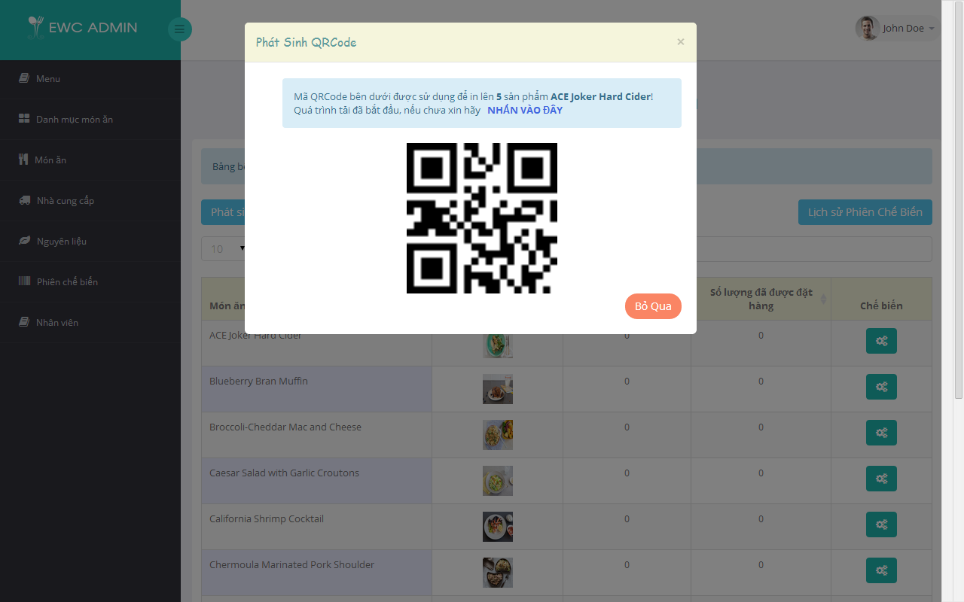

(1)

(4)

(2)

(3)

(5)

Figure 5.11: Generate QRCode screen

|  |  |  |  |
| --- | --- | --- | --- |
| **No.** | **Name** | **Type** | **Description** |
| **1** | Result Message | Paragraph | Message for result of Create Produce Session |
| **2** | Name | Label | Dish Name |
| **3** | Download QRCode | Link | Download QRCode for produced Dishes |
| **4** | QRCode | Image | QRCode image for the produced Dishes |
| **5** | “Bỏ Qua” | Button | Force to skip downloading QRCode image |

Table 5-1: Generate QRCode screen description

* + - * 1. View Produce Session History

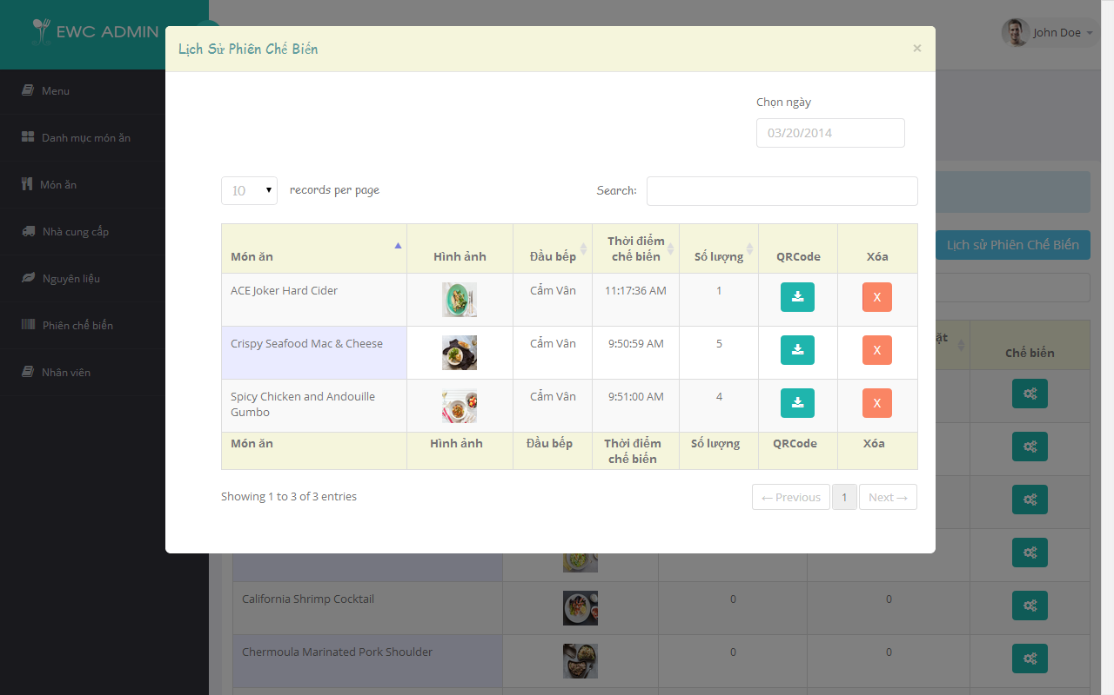

(1)

(4)

(3)

(2)

(6)

(7)

(5)

Figure 5.11: View Produce Session History screen

|  |  |  |  |
| --- | --- | --- | --- |
| **No.** | **Name** | **Type** | **Description** |
| **1** | “Chọn ngày” | Date Picker | Pick the date and system will display all Produce Session in that day |
| **2** | Records per page | Drop down list | Number of Produce Session displayed per page of table |
| **3** | “Tìm Kiếm” | Textbox | Search by Dish name, Chef, Cooking Time and Quantity |
| **4** | List of Produce Session | Gridview | Contains Produce Session that match filter conditions. |
| **5** | Paging | Buttons | Go to selected page |
| **6** | “QRCode” | Button | Re-download QRCode image |
| **7** | “Xóa” | Button | Delete Produce Session |

Table 5-1: View Produce Session History screen description

* + - * 1. Track dish

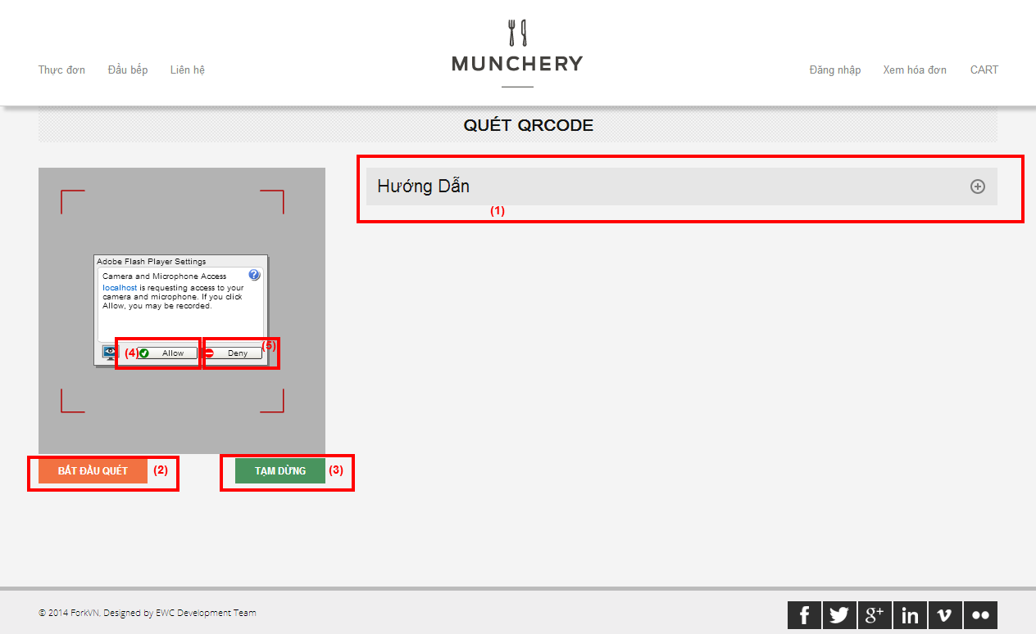

Figure 5.11: Scan QRCode screen

|  |  |  |  |
| --- | --- | --- | --- |
| **No.** | **Name** | **Type** | **Description** |
| **1** | “Hướng dẫn” | Panel | Click to view instructions to scan qrcode |
| **2** | “Bắt đầu quét” | Button | Start scanning qrcode |
| **3** | “Tạm dừng” | Button | Stop scanning qrcode |
| **4** | “Allow” | Button | Allow web browser to access computer webcam |
| **5** | “Deny | Button | Deny web browser to access computer webcam |

Table 5-1: Scan QRCode description

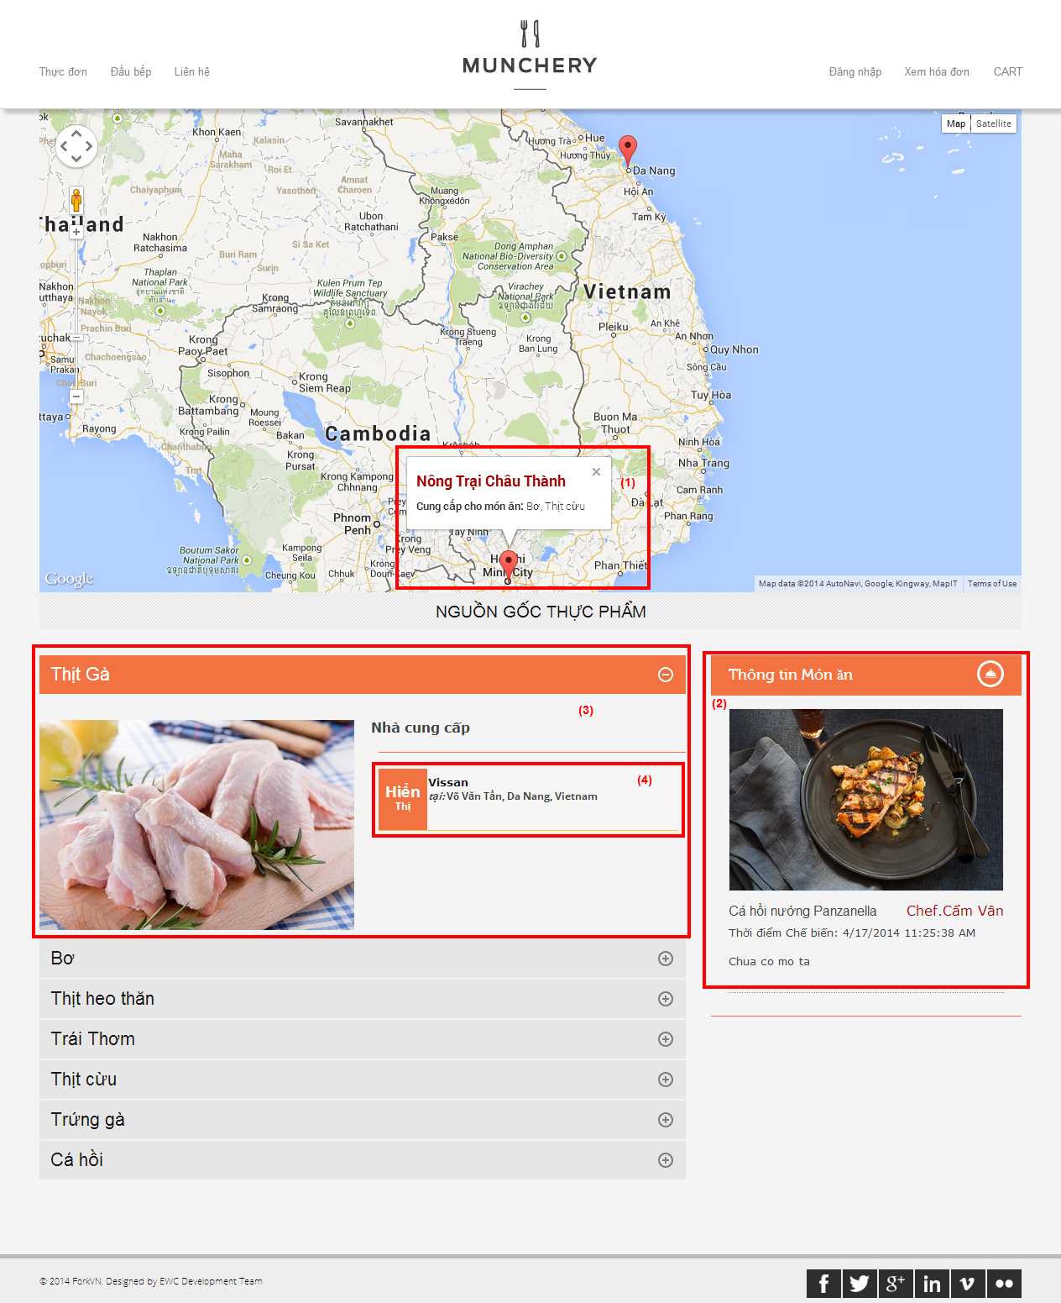

Figure 5.11: Track dish origin screen

|  |  |  |  |
| --- | --- | --- | --- |
| **No.** | **Name** | **Type** | **Description** |
| **1** | Supplier | Pin (GG Maps) | Supplier location and its product |
| **2** | “Thông tin món ăn” | Panel | Basic information about dish and its cooking time, cooked chef |
| **3** | Ingredient panel | Panel | Contains information of ingredients to cook dish |
| **4** | Supplier | Label | Click to view supplier in the maps |

Table 5-1: Track dish origin description

* + - 1. Show Dish



* + - 1. Create Dish



* + - 1. Update Dish



* + - 1. Delete Dish



* + - 1. Show Dish of Today Menu



* + - 1. Create Produce Session



* + - 1. View Produce Session History



### Manage Dish

| **ID** | **Test Case Description** | **Test Case Procedure** | **Expected Output** | **Dependence** | **Result** | **Test Date** |
| --- | --- | --- | --- | --- | --- | --- |
|  | **Show Dish** |  |  |  |  |  |
| SD001 | Test viewing Dish with filter conditions successfully. | 1. Chef clicks “Món Ăn” in the menu bar.  2. Chef types “banh” in the search input.  3. Chef choose page 2.  4. Chef selects “Giá: thấp đến cao” in order filter  5. Chef selectes “Món ăn chính” in Category filter | 1. “Quản lý Món Ăn” page shows up.  2. All Dish contain the word “banh” in their name shown in the grid view.  3. Go to page 2 of the result Dishes.  4. Sort price of list Dish from low to high  5. No result will be found |  |  | 25/07/2013 |
|  | **Create Dish** |  |  |  |  |  |
| CD001 | Test creating a new Dish successfully. | 1. Chef clicks “Tạo mới” buton.  2. Chef types “Thịt kho tàu” for “Tên”, choose “Món Ăn Chính” for “Danh mục”, “50000” for “Giá”, “Chưa có” for “Mô tả” and “Cách nấu”, choose an image for “Hình ảnh” then click “Tiếp tục”  3. Chef drag “Thịt heo thăn” to Ingredient container then clicks “Thêm mới”. | 1. “Thêm Món Ăn” panel shows up with “Thông tin Món Ăn” tab.  2. Slide to “Chọn nguyên liệu” tab.  3. A message “Thao tác thành công” appear in the screen and “Thêm Món Ăn” panel go away. | SD001 |  | 30/07/2013 |
| CD002 | Test error message appear if there are empty fields. | 1. Chef clicks “Tạo mới” buton.  2. Chef leave all field empty then click “Tiếp tục”  3. Chef clicks “Thêm mới”. | 1. “Thêm Món Ăn” panel shows up with “Thông tin Món Ăn” tab.  2. Slide to “Chọn nguyên liệu” tab.  3. Error message “Tên món ăn không được TRỐNG!” for “Tên”. Error message “Số dương!” for “Giá”. Error message “Xin hãy nhập nội dung!” for “Mô tả” and “Cách nấu”. | SD001 |  |  |
| CD003 | Test error message appear if Dish name is existed. | 1. Chef clicks “Tạo mới” buton.  2. Chef types “Súp cà rốt Masala”. | 1. “Thêm Món Ăn” panel shows up with “Thông tin Món Ăn” tab.  2. Error message “Tên này đã tồn tại” shows up next to “Tên” field. | SD001 |  |  |
| CD004 | Test message appear if no Ingredient is selected | 1. Chef clicks “Tạo mới” buton.  2. Chef types “Thịt kho tàu” for “Tên”, choose “Món Ăn Chính” for “Danh mục”, “50000” for “Giá”, “Chưa có” for “Mô tả” and “Cách nấu”, choose an image for “Hình ảnh” then click “Tiếp tục”  3. Chef clicks “Thêm mới”. | 1. “Thêm Món Ăn” panel shows up with “Thông tin Món Ăn” tab.  2. Slide to “Chọn nguyên liệu” tab.  3. The message “Kéo thả nguyên liệu vào đây” fade in and fade out 3 times. | SD001 |  |  |
|  | **Update Dish** |  |  |  |  |  |
| UD001 | Test udpating a Dish successfully. | 1. Chef clicks “Thịt kho tàu” Dish.  2. Chef modifies “Thịt kho trứng” for “Tên”, “60000” for “Giá then click “Tiếp tục”  3. Chef drag “Trứng gà” to Ingredient container then clicks “Chỉnh sửa”. | 1. “Sửa thông tin Món Ăn” panel shows up with “Thông tin Món Ăn” tab.  2. Slide to “Chọn nguyên liệu” tab.  3. A message “Thao tác thành công” appear in the screen and “Sửa thông tin Món Ăn” panel go away. |  |  | 30/07/2013 |
| UD002 | Test error message appear if there are empty fields. | 1. Chef clicks “Atiso nướng Castroville”.  2. Chef leave all field empty then click “Tiếp tục”  3. Chef clicks “Chỉnh sửa”. | 1. “Sửa thông tin Món Ăn” panel shows up with “Thông tin Món Ăn” tab.  2. Slide to “Chọn nguyên liệu” tab.  3. Error message “Tên món ăn không được TRỐNG!” for “Tên”. Error message “Số dương!” for “Giá”. Error message “Xin hãy nhập nội dung!” for “Mô tả” and “Cách nấu”. | SD001 |  | 30/07/2013 |
| UD003 | Test error message appear if Dish name is existed. | 1. Chef clicks “Atiso nướng Castroville”.  2. Chef types “Súp cà rốt Masala”. | 1. “Sửa thông tin Món Ăn” panel shows up with “Thông tin Món Ăn” tab.  2. Error message “Tên này đã tồn tại” shows up next to “Tên” field. | SD001 |  | 30/07/2013 |
| UD004 | Test message appear if no Ingredient is selected | 1. Chef clicks “Atiso nướng Castroville”.  2. Chef click “Tiếp tục”.  3. Chef removes all Ingredient from Ingredient container then clicks “Chỉnh sửa”. | 1. “Sửa thông tin Món Ăn” panel shows up with “Thông tin Món Ăn” tab.  2. Slide to “Chọn nguyên liệu” tab.  3. The message “Kéo thả nguyên liệu vào đây” fade in and fade out 3 times. | SD001 |  | 30/07/2013 |
|  | **Delete Dish** |  |  |  |  |  |
| DD001 | Chef can delete a Dish | 1. Chef clicks “Thịt kho tàu” Dish.  2. Chef clicks “Xóa” button.  3. Chef clicks “Ok” | 1. “Sửa thông tin Món Ăn” panel shows up with “Thông tin Món Ăn” tab.  2. A confirm message appears  3. A message “Thao tác thành công” appear in the screen. |  |  | 30/07/2013 |

### Manage Produce Session

| **ID** | **Test Case Description** | **Test Case Procedure** | **Expected Output** | **Dependence** | **Result** | **Test Date** |
| --- | --- | --- | --- | --- | --- | --- |
|  | **Show Dish of Today Menu** |  |  |  |  |  |
| SDTM001 | Test viewing Dish of Today Menu with filter conditions successfully. | 1. Chef clicks “Phiên Chế Biến” in the menu bar.  2. Chef choose page 2.  3. Chef types “bánh” in the search input.  4. Chef types “bánh bèo” in the search input. | 1. “Quản lý Phiên Chế Biến” page shows up with all Dish in Menu for today.  2. Go to page 2 of the result Dishes.  3. List of Dish that its name contains “bánh” show up.  4. Message “Không tìm thấy” shows up. |  |  | 25/07/2013 |
| SDTM002 | Test message appear if there is no Menu for today. | 1. Chef clicks “Phiên Chế Biến” in the menu bar. | 1. Message “Rất tiếc! Menu của ngày hôm nay chưa được chuẩn bị. Xin chuẩn bị menu và quay lại sau!” shows up. |  |  |  |
|  | **Auto Generate Produce Session** |  |  |  |  |  |
| AGPS001 | Test generating Produce Session automatically. | 1. Chef clicks “Phát sinh tự động” button.  2. Chef clicks “OK”. | 1. Message “Bạn có muốn tự động tạo Phiên Chế Biến!” shows up.  2. Produce Session for all ordered Dish are created and message “Tự động phát sinh Phiên Chế Biến thành công!” shows up. | SDTM001 |  |  |
|  | **Create Produce Session** |  |  |  |  |  |
| CPS001 | Test creating a new Produce Session successfully. | 1. Chef clicks “Chế biến” buton of “Bánh Bran Muffin”.  2. Chef leaves defaults “Số lượng” as “5” and “Nhà cung cấp cho Thịt cừu” as “Nông trại Châu Thành” then clicks “Chế biến”. | 1. “Tạo Phiên Chế Biến” for “Bánh Bran Muffin” panel shows up.  2. Panel “Phát sinh QRCode” appear in the screen with QRCode image for 5 “Bánh Bran Muffin” then QRCode image is saved automatically. | SDTM001 |  | 30/07/2013 |
| CPS002 | Test error message appear if there are empty fields. | 1. Chef clicks “Chế biến” buton of “Bánh Bran Muffin”.  2. Chef leaves “Số lượng” as empty and “Nhà cung cấp cho Thịt cừu” as empty then clicks “Chế biến”. | 1. “Tạo Phiên Chế Biến” for “Bánh Bran Muffin” panel shows up.  2. Error message “Số dương!” for “Số lượng” and “Chọn nhà cung cấp cho Thịt cừu” turns to red. | SDTM001 |  |  |
| CPS003 | Test leaving input as default if “Khôi phục mặc định” button is clicked | 1. Chef clicks “Chế biến” buton of “Bánh Bran Muffin”.  2. Chef leaves “Số lượng” as empty and “Nhà cung cấp cho Thịt cừu” as empty then clicks “Khôi phục mặc định”. | 1. “Thêm Món Ăn” panel shows up with “Thông tin Món Ăn” tab.  2. Defaults are restored: “Số lượng” as “5” and “Nhà cung cấp cho Thịt cừu” as “Nông trại Châu Thành”. | SDTM001 |  |  |
|  | **View Produce Session History** |  |  |  |  |  |
| VPSH001 | Test viewing Produce Session with filter conditions successfully. | 1. Chef clicks “Lịch sử Phiên Chế Biến” button.  2. Chef pick tomorrow from datepicker “Chọn ngày”. | 1. “Lịch sử Phiên Chế Biến” panel shows up with all Produce Session in today.  2. There is no record appear and the message “Chưa có Phiên Chế Biến nào” shows up. | SDTM001 |  | 25/07/2013 |
| VPSH002 | Test downloading QRCode for Produce Session successfully. | 1. Chef clicks “Lịch sử Phiên Chế Biến” button.  2. Chef clicks “QRCode” button of the first “Bánh Bran Muffin”. | 1. “Lịch sử Phiên Chế Biến” panel shows up with all Produce Session in today.  2. A download of QRCode image for “Bánh Bran Muffin” will be started. | VPSH001 |  | 25/07/2013 |
| VPSH003 | Test deleting Produce Session successfully. | 1. Chef clicks “Lịch sử Phiên Chế Biến” button.  2. Chef clicks “Xóa” button of the first “Bánh Bran Muffin”.  3. Chef clicks “OK” button. | 1. “Lịch sử Phiên Chế Biến” panel shows up with all Produce Session in today.  2. The confirm message “Bạn có thực sự muốn xóa Phiên Chế Biến này không” shows up.  3. Produce Session for the first “Bánh Bran Muffin” is deleted and disappear from the table. | VPSH001 |  | 25/07/2013 |

* + - * 1. Show Dish

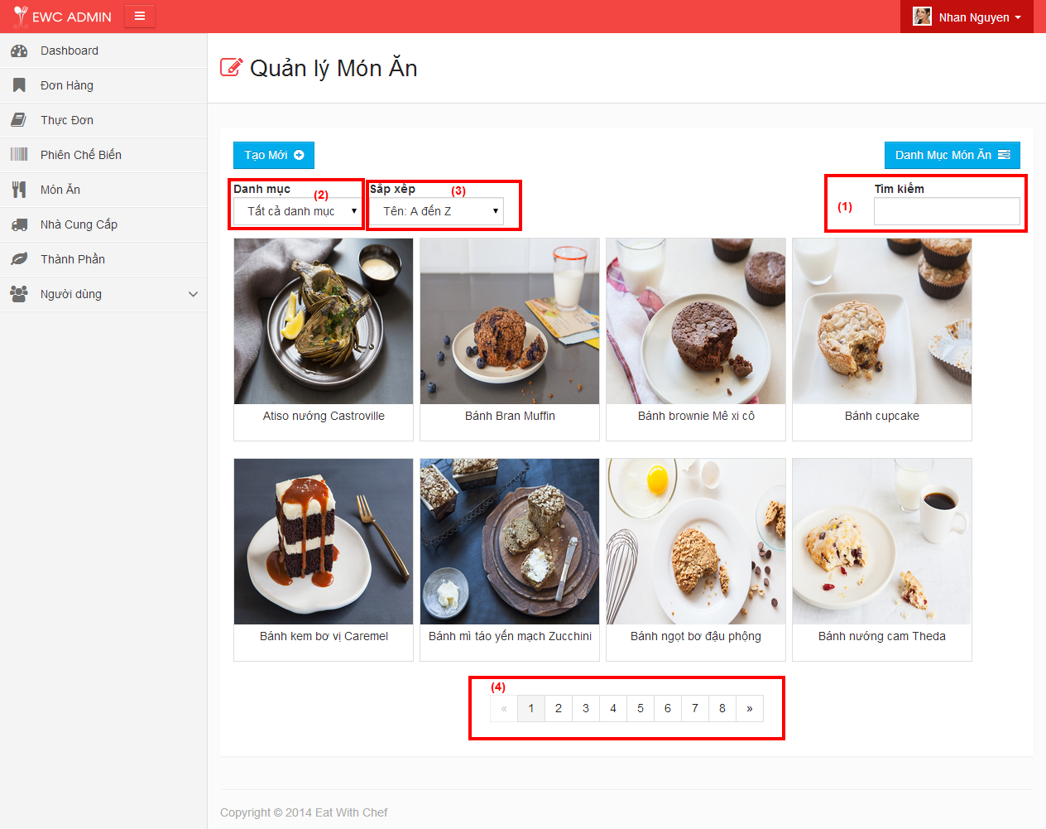

Figure 5.11: Show Dish

| **STEP** | **DESCRIPTION** |
| --- | --- |
| **1** | Type keyword to search for Dish |
| **2** | Select one option to filter Dish by Category. |
| **3** | Select one option to sort all result Dish |
| **4** | Select page of result list that user want to visit. |

Table 7-10: Show Dish steps

* + - * 1. Create Dish

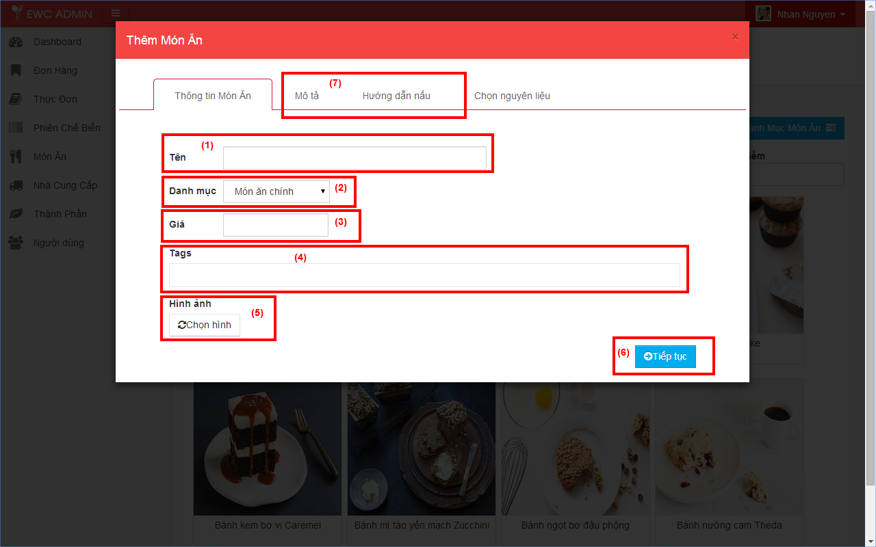

Figure 5.11: Create Dish Information

| **STEP** | **DESCRIPTION** |
| --- | --- |
| **1** | Fill “Tên” field (required) |
| **2** | Select one option of “Danh mục” field |
| **3** | Fill “Giá” (required) |
| **4** | Type or select “Tags” (optional) |
| **5** | Click “Chọn hình” to choose an image for Dish |
| **6** | Click “Tiếp tục” button |
| **7** | Fill “Mô tả” and “Hướng dẫn nấu” tabs (optional) |

Table 5-1: Create Dish Information steps

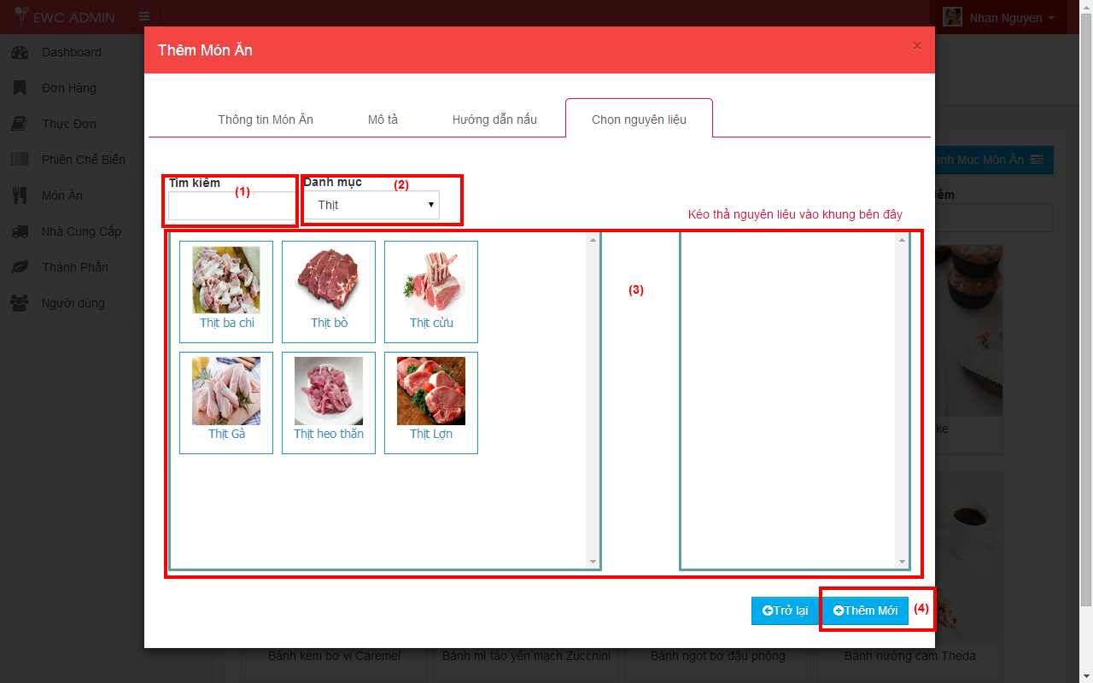

Figure 5.11: Choose Ingredients for Dish

| **STEP** | **DESCRIPTION** |
| --- | --- |
| **1** | Type in keyword want to search for Ingredient |
| **2** | Select one option to filter Ingredient Category |
| **3** | Drag and drop Ingredients to the right container |
| **4** | Click “Thêm mới” button |

Table 5-1: Choose Ingredients for Dish steps

* + - * 1. Update Dish (deleted)



(1)

(2)

(3)

(4)

(5)

(6)

(7)

(8)

Figure 5.11: Update Dish Information (deleted)

| **STEP** | **DESCRIPTION** |
| --- | --- |
| **1** | Fill “Tên” field (required) |
| **2** | Select one option of “Danh mục” field |
| **3** | Fill “Giá” (required), “Mô tả” and “Cách nấu” field (optional) |
| **4** | Type or select “Tags” (optional) |
| **5** | Click “Chọn hình” to choose an image for Dish |
| **6** | Click “Tiếp tục” button |

Table 5-1: Update Dish Information steps (deleted)



(1)

(2)

(3)

(4)

Figure 5.11: Choose Ingredients for Dish

| **STEP** | **DESCRIPTION** |
| --- | --- |
| **1** | Type in keyword want to search for Ingredient |
| **2** | Select one option to filter Ingredient Category |
| **3** | Drag and drop Ingredients to the right container |
| **4** | Click “Chỉnh sửa” button |

Table 5-1: Choose Ingredients for Dish steps

* + - * 1. Delete Dish

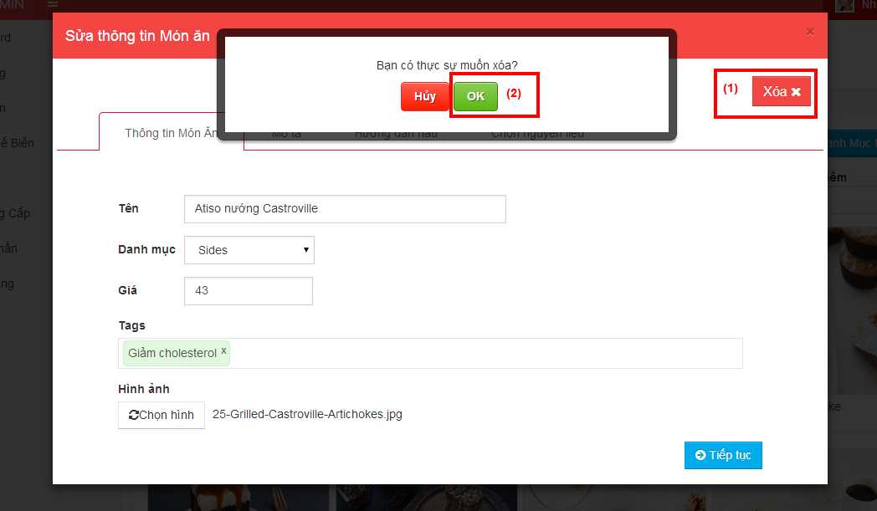

Figure 5.11: Delete Dish Category

| **STEP** | **DESCRIPTION** |
| --- | --- |
| **1** | Click “Xoá” button |
| **2** | Click “Ok” button to confirm deleting |

Table 5-1: Delete Dish steps

* + - * 1. Show Dish of Today Menu

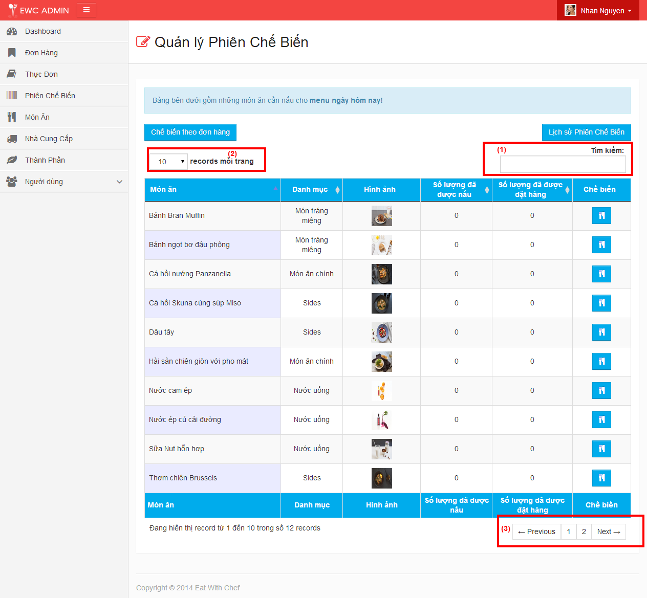

Figure 5.11: Show Dish of Today Menu

| **STEP** | **DESCRIPTION** |
| --- | --- |
| **1** | Type keyword to search for Dish of Today Menu |
| **2** | Select one option to set number of Dish in a page |
| **3** | Select page of result list that user want to visit. |

Table 5-1: Show Dish of Today Menu steps

* + - * 1. Generate Produce Session

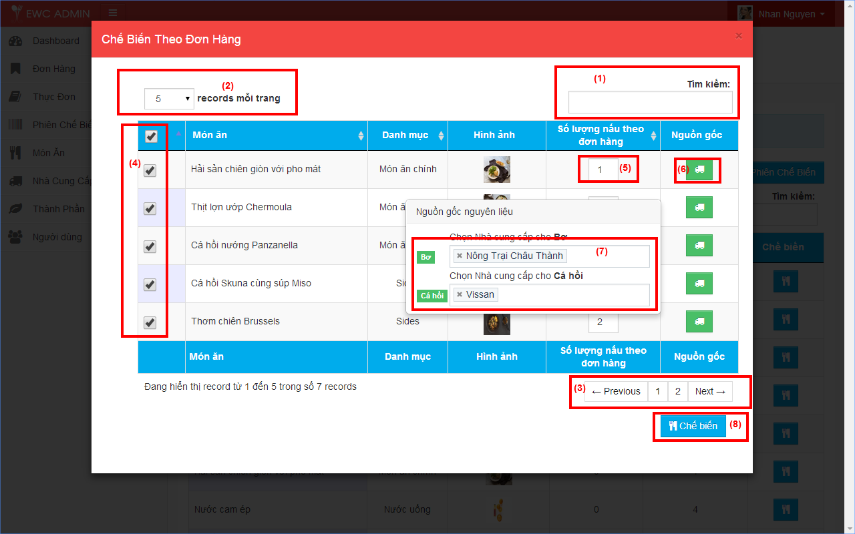

Figure 5.11: Generate Produce Session

| **STEP** | **DESCRIPTION** |
| --- | --- |
| **1** | Type keyword to search for Dish |
| **2** | Select one option to set number of Dish in a page |
| **3** | Select page of result list that user want to visit. |
| **4** | Select dishes that will be cooked |
| **5** | Type the quantity for each dish |
| **6** | Click “Nguồn gốc” button to show “Nguồn gốc nguyên liệu” panel |
| **7** | Select supplier for each ingredient used to cook dish |
| **8** | Click “Chế biến” button |

Table 5-1: Generate Produce Session steps

* + - * 1. Create Produce Session

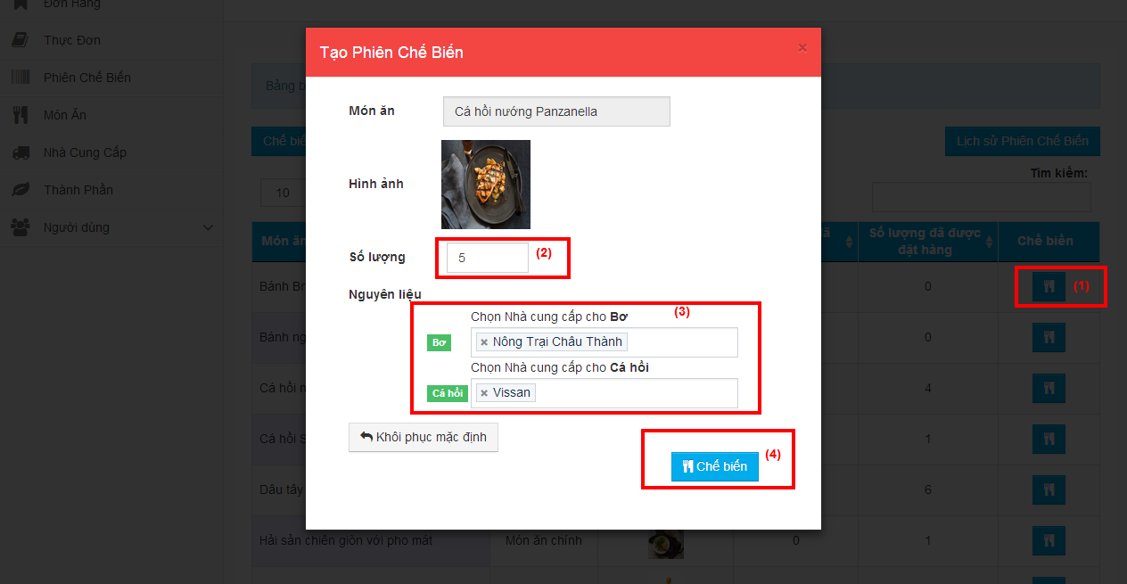

Figure 5.11: Create Session

| **STEP** | **DESCRIPTION** |
| --- | --- |
| **1** | Click “Chế biến” button |
| **2** | Type the quantity for each dish |
| **3** | Select supplier for each ingredient used to cook dish |
| **4** | Click “Chế biến” button |

Table 5-1: Create Produce Session steps

* + - * 1. View Produce Session History

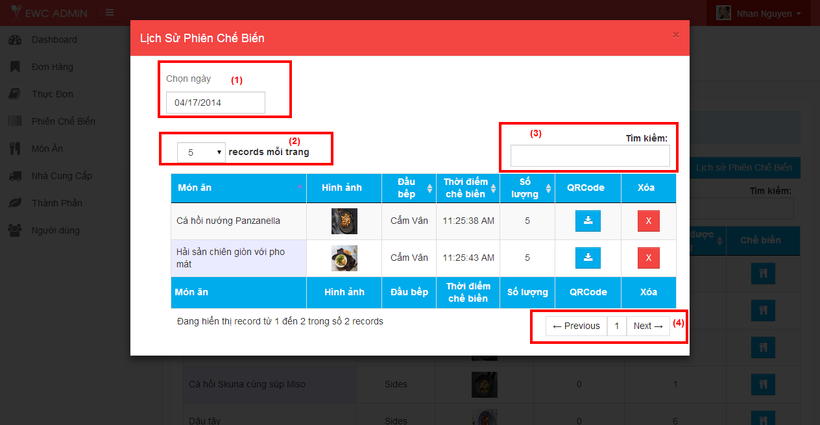

Figure 5.11: View Produce Session History

| **STEP** | **DESCRIPTION** |
| --- | --- |
| **1** | Pick a date to view all Produce Session made in that day |
| **2** | Select one option to set number of Dish in a page |
| **3** | Type keyword to search for Dish of Today Menu |
| **4** | Select page of result list that user want to visit. |

Table 5-1: View Produce Session History steps

* + - * 1. Track Dish

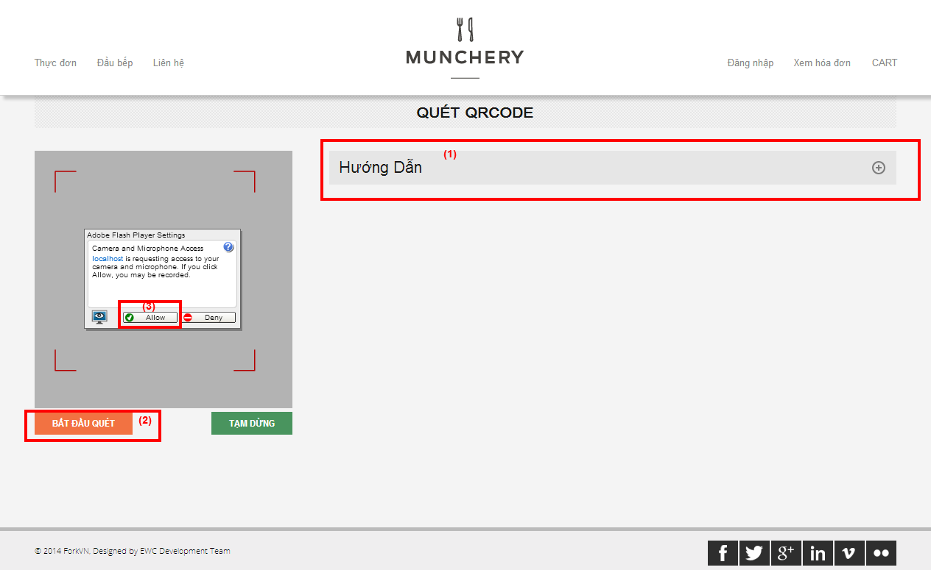

Figure 5.11: Scan QRCode

| **STEP** | **DESCRIPTION** |
| --- | --- |
| **1** | Click “Hướng dẫn” to view instructions |
| **2** | Click “Bắt đầu quét” |
| **3** | Click “Allow” |
| **4** | Place the qrcode in front of webcam |

Table 5-1: Scan QRCode steps

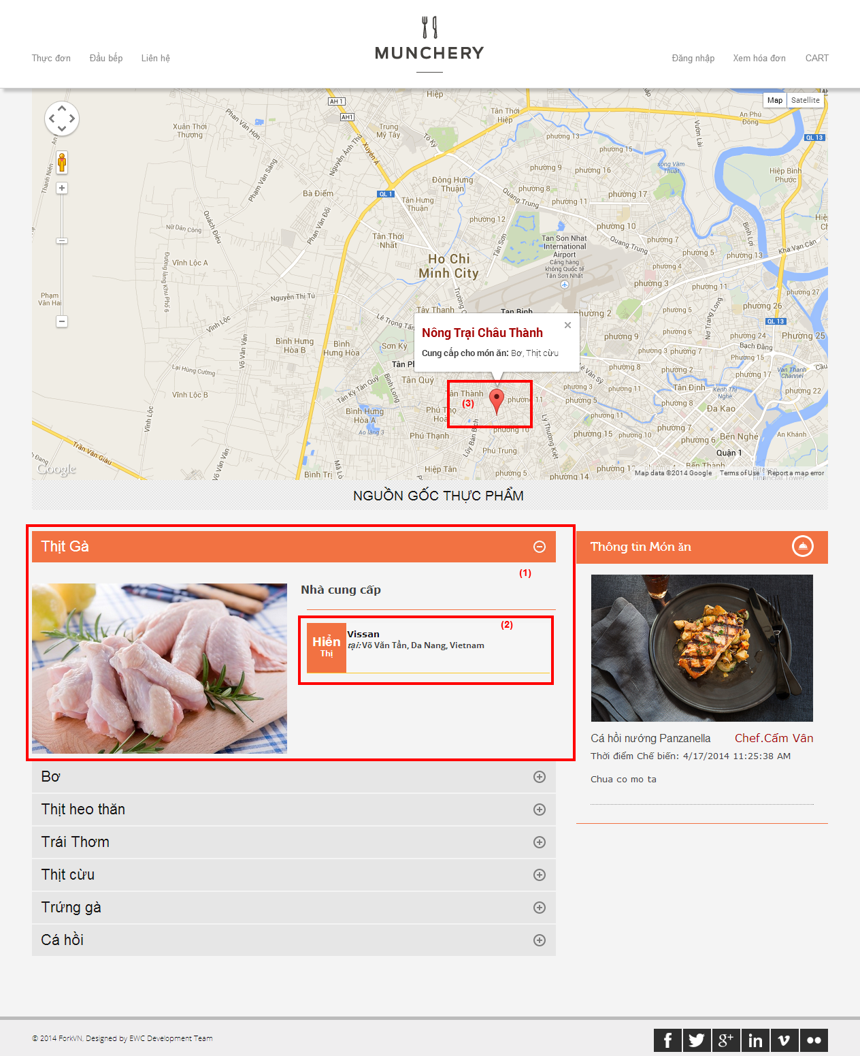

Figure 5.11: View Dish Origin

| **STEP** | **DESCRIPTION** |
| --- | --- |
| **1** | Click ingredient panel to show up ingredient origin information |
| **2** | Click “Hiển thị” to view the supplier on map |
| **3** | Click on any pin to view supplier information |

Table 5-1: View dish origin steps

# 5. Class Diagram

## 5.1 Dish Management:



##### DishManagementController

|  |  |
| --- | --- |
| Class name | DishManagementController |
| Description | This class provides user interfaces to execute all actions of Dish. |
| **Attribute**:   |  |  |  |  | | --- | --- | --- | --- | | **Attribute** | **Attribute Type** | **Data Type** | **Description** | | dishReposity | DataAccess | IDishRepository | Access database for managing Dish | | |
|  | |
| **Methods**:  *public ActionResult Index():* Get view of dish.   |  |  |  | | --- | --- | --- | | **Parameter/Return** | **Type** | **Description** | | Return | ActionResult | View of dish |   *public JsonResult GetDishes(string keyword, int categoryID, string sortBy,* *string sortDirection, int page):* Get list of all dish match the conditions.   |  |  |  | | --- | --- | --- | | **Parameter/Return** | **Type** | **Description** | | Return | JsonResult | List of dish after filter and search. | | keyword | String | Search for dish by name | | categoryID | Integer | Category of dish | | sortBy | String | Sorting list of dish | | sortDirection | String | Sort direction | | page | Integer | Page of result |   *public JsonResult CheckDishName(string name, int dishid):*check for existed dish name.   |  |  |  | | --- | --- | --- | | **Parameter/Return** | **Type** | **Description** | | Return | JsonResult | “Success”: dish name is not existed  “Error”: dish name is existed | | name | String | Dish name | | dishid | Interger | Use for check dish name while updating an old dish |   *public ActionResult CreateDish(): response create dish view*.   |  |  |  | | --- | --- | --- | | **Parameter/Return** | **Type** | **Description** | | Return | ActionResult | Return View to create supplier.  Return error page in case exception |   *public JsonResult CreateDish(FormCollection col): create new dish*.   |  |  |  | | --- | --- | --- | | **Parameter/Return** | **Type** | **Description** | | Return | JsonResult | “SUCCESS” / “ERROR” | | col | FormCollection | Contains all information to create new dish include ingredients to make dish |   *public ActionResult UpdateDish(int DishID):* response update dish view   |  |  |  | | --- | --- | --- | | **Parameter/Return** | **Type** | **Description** | | Return | ActionResult | Partial view for updating dish | | DishID | Interger | Identify of the dish need to be updated |   *public JsonResult UpdateDish(FormCollection col):*update dish.   |  |  |  | | --- | --- | --- | | **Parameter/Return** | **Type** | **Description** | | Return | JsonResult | “Success” / “Error” | | col | FormCollection | Contains all information to update an existed dish include ingredients to make dish |   *public JsonResult DeleteDish(int id):* delete an existed dish but still store it in database.   |  |  |  | | --- | --- | --- | | **Parameter/Return** | **Type** | **Description** | | Return | JsonResult | “Success” / “Error” | | id | Interger | Identify of the dish need to be deleted |   *public JsonResult LoadTags(string tagName):* get list of Tag item by their name.   |  |  |  | | --- | --- | --- | | **Parameter/Return** | **Type** | **Description** | | Return | JsonResult | Return List of Tag item after searching. | | tagName | String | Keyword for name of Tag. | | |

##### DishRepository

|  |  |
| --- | --- |
| Class name | DishReposity |
| Description | This class execute all actions of Dish in database. |
| **Attribute**:   |  |  |  |  | | --- | --- | --- | --- | | **Attribute** | **Attribute Type** | **Data Type** | **Description** | | _dbContext | Database Context | EWCEntities | Communicate with database to execute actions of dish | | |
|  | |
| **Methods**:  *public List<Dish> GetDishes(string keyword, int categoryID, string sortBy,* *string sortDirection, int page):* Get list of all dish match the conditions.   |  |  |  | | --- | --- | --- | | **Parameter/Return** | **Type** | **Description** | | Return | List<Dish> | List of dish after filter and search. | | keyword | String | Search for dish by name | | categoryID | Integer | Category of dish | | sortBy | String | Sorting list of dish | | sortDirection | String | Sort direction | | page | Integer | Page of result |   *public bool CheckDishName(string name, int dishid):*check for existed dish name.   |  |  |  | | --- | --- | --- | | **Parameter/Return** | **Type** | **Description** | | Return | Boolean | true: dish name is not existed  false: dish name is existed | | name | String | Dish name | | dishid | Interger | Use for check dish name while updating an old dish |   *public bool CreateDish(string name, int categoryID, int price, string description, string cookingGuide, int chefID, string image, string tagList, string[] selected_ingredient): create new dish*.   |  |  |  | | --- | --- | --- | | **Parameter/Return** | **Type** | **Description** | | Return | Boolean | true: dish is created successfully  false: exception occurred | | name | String | Dish name | | categoryID | Integer | Dish category | | price | Integer | Dish price. | | description | String | Dish description. Default is “Chưa có mô tả” | | cookingGuide | String | Dish cooking guide. Default is “Chưa có hướng dẫn” | | chefID | Integer | The chef creates this dish | | image | String | Path store image of dish | | tagList | String | List of tags separate by an special character | | selected_ingredient | String[] | Contains all picked ingredient ids |   *public bool UpdateDish(string name, int categoryID, int price, string description, string cookingGuide, string image, string tagList, string[] selected_ingredient): create new dish*.   |  |  |  | | --- | --- | --- | | **Parameter/Return** | **Type** | **Description** | | Return | Boolean | true: dish is updated successfully  false: exception occurred | | name | String | Dish name | | categoryID | Integer | Dish category | | price | Integer | Dish price. | | description | String | Dish description. Default is “Chưa có mô tả” | | cookingGuide | String | Dish cooking guide. Default is “Chưa có hướng dẫn” | | image | String | Path store image of dish | | tagList | String | List of tags separate by an special character | | selected_ingredient | String[] | Contains all picked ingredient ids |   *public bool DeleteDish(int id):* delete an existed dish but still store it in database.   |  |  |  | | --- | --- | --- | | **Parameter/Return** | **Type** | **Description** | | Return | Boolean | true: dish is deleted successfully  false: exception occurred | | id | Interger | Identify of the dish need to be deleted |   *public List<Tag> GetTagsByName(string name):* get list of Tag item by their name.   |  |  |  | | --- | --- | --- | | **Parameter/Return** | **Type** | **Description** | | Return | List<Tag> | Return List of Tag item after searching. | | name | String | Keyword for name of Tag. |   *public Tag GetOrInsertTag(string name):* get a Tag by name if it is existed. If not create a new one with input name   |  |  |  | | --- | --- | --- | | **Parameter/Return** | **Type** | **Description** | | Return | Tag | Return Tag item after searching or inserting | | name | String | Tag name | | |

## 5.2 Produce Session Management:



##### ProduceSessionManagementController

|  |  |
| --- | --- |
| Class name | ProduceSessionManagementController |
| Description | This class provides user interfaces to execute all actions of produce session. |
| **Attribute**:   |  |  |  |  | | --- | --- | --- | --- | | **Attribute** | **Attribute Type** | **Data Type** | **Description** | | produceSessionReposity | DataAccess | IProduceSessionRepository | Access database for managing produce session | | |
|  | |
| **Methods**:  *public ActionResult TodayMenuProduce():* Get view of dish in today menu.   |  |  |  | | --- | --- | --- | | **Parameter/Return** | **Type** | **Description** | | Return | ActionResult | View of dishes in today menu |   *public JsonResult ProduceSessionGenerate():* filter all dishes in today menu that have been ordered but not produced.   |  |  |  | | --- | --- | --- | | **Parameter/Return** | **Type** | **Description** | | Return | ActionResult | PartialView contains all filtered dishes |   *public JsonResult ProduceSessionGenerate (string json):*create produce sessions for ordered dishes match with chef adjustment.   |  |  |  | | --- | --- | --- | | **Parameter/Return** | **Type** | **Description** | | Return | JsonResult | “Success” / “Error” | | json | String | Contains list of produce session need to be created include all ingredient and supplier |   *public ActionResult CreateProduceSession(int DishID): response view to create produce session for a dish*.   |  |  |  | | --- | --- | --- | | **Parameter/Return** | **Type** | **Description** | | Return | ActionResult | Return PartialView to create produce session.  Return error page in case exception | | DishID | Integer | Identify for the dish need to be produced |   *public JsonResult CreateProduceSessionWithQRCode (int id,int quantity, string ingredients_str): create produce session for a dish and return a view for display/download qrcode image of created produce session*.   |  |  |  | | --- | --- | --- | | **Parameter/Return** | **Type** | **Description** | | Return | JsonResult | Return PartialView of qrcode image | | id | Integer | Identify for the dish need to be produced | | quantity | Integer | Quantity need to be produced | | ingredients_str | String | Contains list of ingredient ids picked by user |   *public ActionResult ProduceSessionHistory(string date):* get all produce session created at selected date and response a partial view   |  |  |  | | --- | --- | --- | | **Parameter/Return** | **Type** | **Description** | | Return | ActionResult | Partial view for list of produce session created in selected date | | date | Date | The picked date for viewing history |   *public JsonResult DeleteProduceSession(int ID): delete a produce session that hasn’t been mapped with an order*.   |  |  |  | | --- | --- | --- | | **Parameter/Return** | **Type** | **Description** | | Return | JsonResult | “Success” / “Error” | | ID | Integer | Identify for the produce session need to be deleted | | |

##### TrackDishController

|  |  |
| --- | --- |
| Class name | TrackDishController |
| Description | This class provides user interfaces to track the origin of ingredients use to cook the dish. |
| **Attribute**:   |  |  |  |  | | --- | --- | --- | --- | | **Attribute** | **Attribute Type** | **Data Type** | **Description** | | produceSessionReposity | DataAccess | IProduceSessionRepository | Access database for tracking dish | | |
|  | |
| **Methods**:  *public ActionResult QRCodeScan():*response a view for scanning QRCode from a product.   |  |  |  | | --- | --- | --- | | **Parameter/Return** | **Type** | **Description** | | Return | ActionResult | Scanning QRCode view |   *public ActionResult TrackDishItem(int dishItemId):*view all ingredients with supplier used to cook the scanned dish.   |  |  |  | | --- | --- | --- | | **Parameter/Return** | **Type** | **Description** | | Return | ActionResult | The view contains all ingredients origin of the dish | | dishItemId | Integer | Identify for the product need to be tracked. This Id is scanned from the qrcode attach to the product | | |

##### ProduceSessionRepository

|  |  |
| --- | --- |
| Class name | ProduceSessionRepository |
| Description | This class execute all actions of produce session in database. |
| **Attribute**:   |  |  |  |  | | --- | --- | --- | --- | | **Attribute** | **Attribute Type** | **Data Type** | **Description** | | _dbContext | Database context | EWCEntities | Communicate with database to execute actions of dish | | |
|  | |
| **Methods**:  *public List<DishItem> GetDishItemByDate(DateTime date) :*Get list of produce session in a date.   |  |  |  | | --- | --- | --- | | **Parameter/Return** | **Type** | **Description** | | Return | List<DishItem> | List of produce session in input date | | date | DateTime | The date for filtering |   *public Menu GetMenuByDate(DateTime date) :*filter all dishes in today menu that have been ordered but not produced.   |  |  |  | | --- | --- | --- | | **Parameter/Return** | **Type** | **Description** | | Return | Menu | Get menu for input date | | date | DateTime | The date for filtering |   *public List<Dish> LoadDishFromMenu(int menuID):*get list of dishes in input menu.   |  |  |  | | --- | --- | --- | | **Parameter/Return** | **Type** | **Description** | | Return | List<Dish> | List of dish belongs to giving menu | | menuID | Integer | Identify for the menu |   *public DishItem GetDishItemById(int dishItemId) :get a produce session by its Id*.   |  |  |  | | --- | --- | --- | | **Parameter/Return** | **Type** | **Description** | | Return | DishItem | Produce session | | dishItemId | Integer | Identify for the produce session |   *public int CalculateNumberProducedDishItemOfMenu(Menu menu, int dishID) : calculate number of giving dish that have been produced for input menu*.   |  |  |  | | --- | --- | --- | | **Parameter/Return** | **Type** | **Description** | | Return | Integer | Number of produced dish  -1 for error | | menu | Menu | Menu | | dishID | Integer | Identify for the dish |   *public int CalculateNumberOrderedDishItem (Menu menu, int dishID) : calculate number of giving dish that have been ordered in input menu*.   |  |  |  | | --- | --- | --- | | **Parameter/Return** | **Type** | **Description** | | Return | Integer | Number of ordered dish  -1 for error | | menu | Menu | Menu | | dishID | Integer | Identify for the dish |   *public List<IngredientItem> GetAvailableIngredientItemForDish(int dishId): get list of ingredient include supplier for the giving dish*.   |  |  |  | | --- | --- | --- | | **Parameter/Return** | **Type** | **Description** | | Return | List<IngredientItem> | List of ingredient include supplier | | dishId | Integer | Identify for the dish |   *public DishItem ProduceDishItem(int dishID, int quantity, string ingredients_str): create produce session with giving information*.   |  |  |  | | --- | --- | --- | | **Parameter/Return** | **Type** | **Description** | | Return | DishItem | Just created produce session | | dishID | Integer | Identify for the dish | | quantity | Integer | Quantity need to be produced | | ingredients_str | String | Contains all picked ingredient ids |   *public bool ProduceSessionGenerate(List<ProduceSessionGenerateDTO> ListProduceSessionGenerateDTO, string serverPath):create list of produce session with giving information*.   |  |  |  | | --- | --- | --- | | **Parameter/Return** | **Type** | **Description** | | Return | Boolean | Success / Exception | | ListProduceSessionGenerateDTO | List<ProduceSessionGenerateDTO> | Contains all information to create sessions | | serverPath | String | Path to folder for storing qrcode image |   *public bool CreateQRCodeForDishItem(DishItem dishItem, string path): create qrcode for the giving produce session*.   |  |  |  | | --- | --- | --- | | **Parameter/Return** | **Type** | **Description** | | Return | Boolean | Success / Exception | | dishItem | DishItem | Produce session | | serverPath | String | Path to folder for storing qrcode image |   *public bool DeleteDishItem(int dishItemId): delete a produce session that hasn’t been mapped with the order*.   |  |  |  | | --- | --- | --- | | **Parameter/Return** | **Type** | **Description** | | Return | Boolean | Success / Exception | | dishItemId | Integer | Identify for the produce session | | |

## 6.6. Checklist

### 6.6.1. Checklist of Validation

| Question | Yes | No | N/A |
| --- | --- | --- | --- |
| 1. Does a failure of validation on every field cause a sensible user error symbol? | X |  |  |
| 2. Is the user required to fix entries which have failed validation tests? | X |  |  |
| 3. Have any fields got multiple validation rules and if so are all rules being applied? | X |  |  |
| 4. If the user enters an invalid value and clicks on the insert button is the invalid entry identified and highlighted correctly with an error symbol? | X |  |  |
| 5. Is validation consistently applied at screen level unless specifically required at field level? | X |  |  |
| 6. For all numeric fields check whether negative numbers can and should be able to be entered. | X |  |  |
| 7. For all numeric fields check the minimum and maximum values and also some mid-range values allowable? |  | X |  |
| 8. For all character/alphanumeric fields check the field to ensure that there is a character limit specified and that this limit is exactly correct for the specified database size? | X |  |  |
| 9. Do all mandatory fields require user input? | X |  |  |
| 10. If any of the database columns do not allow null values then the corresponding screen fields must be mandatory. (If any field which initially was mandatory has become optional then check whether null values are allowed in this field.) | X |  |  |

### 6.6.2. Submission Checklist

| Question | | Yes | No | N/A |
| --- | --- | --- | --- | --- |
| TABLES AND FIGURES | | | | |
| 1 | Does every table column, including the stub column, have a heading? | X |  |  |
| 2 | Are all tables referred to in text? | X |  |  |
| 3 | Are the elements in the figures large enough to remain legible after the figure has been reduced to the width of a journal column or page? |  |  | X |
| 4 | Is lettering in a figure no smaller than 8 points and no larger than 14 points? |  | X |  |
| 5 | Are the figures being submitted in a file format acceptable to the publisher? |  |  | X |
| 6 | Has the figure been prepared at a resolution sufficient to produce a high-quality image? |  |  | X |
| 7 | Are all figures numbered consecutively with Arabic numerals? |  | X |  |
| 8 | Are all figures and tables mentioned in the text and numbered in the order in which they are mentioned? | X |  |  |
| REFERENCES | | | | |
| 1 | Are references cited both in text and in the reference list? |  |  | X |
| 2 | Do the text citations and reference list entries agree both in spelling and in date? |  |  | X |
| 3 | Are journal titles in the reference list spelled out fully? |  | X |  |
| 4 | Are the references (both in the parenthetical text citations and in the reference list) ordered alphabetically by the authors’ surnames? |  | X |  |
| 5 | Are inclusive page numbers for all articles or chapters in books provided in the reference list? |  | X |  |
| 6 | Are references to studies included in your meta-analysis preceded by an asterisk? |  | X |  |
| FORMAT | | | | |
| 1 | Have you checked the journal’s website for instructions to authors regarding specific formatting requirements for submission? |  | X |  |
| 2 | Is the entire manuscript—including quotations, references, author note, content footnotes, and figure captions—double-spaced? Is the manuscript neatly prepared? |  | X |  |
| 3 | Are the margins at least 1 in. (2.54 cm)? |  |  | X |
| 4 | Are the title pages, abstracts, references, appendices, content footnotes, tables, and figures on separate pages (with only one table or figure per page)? Are the figure captions on the same page as the figures? Are manuscript elements ordered in sequence, with the text pages between the abstract and the references? | X |  |  |
| 5 | Are all pages numbered in sequence, starting with the title page? | X |  |  |
| PARAGRAPHS AND HEADINGS | | | | |
| 1 | Is each paragraph longer than a single sentence but not longer than one manuscript page? |  |  | X |
| 2 | Do the levels of headings accurately reflect the organization of the paper? | X |  |  |
| 3 | Do all headings of the same level appear in the same format? | X |  |  |